EXHIBIT “A”

TREE PRESERVATION AND LANDSCAPE ORDINANCE
CITY OF CONYERS, GEORGIA
Title 8, Chapter 10

OCTOBER 4, 2000

Prepared for:

Department of Planning and City Services
Conyers, GA

Prepared by:
Hughes, Good, O'Leary & Ryan, Inc.
Atlanta, GA
Acknowledgements

Special thanks to the City of Conyers Department of Planning and City Services, Planning Commission, City Council members, as well as the many citizens and other interested individuals who participated in the culmination of this document.

Because of your insight and review process, this ordinance will serve to help implement the community vision. We are proud to have been a part of such a worthwhile effort.

Hughes, Good, O’Leary & Ryan, Inc.
11 Executive Park Drive, Suite 100
Atlanta, GA 30329
(404) 248-1960

Many ordinances were referenced as part of this research effort; however, we would like to specifically credit the following city’s tree, buffer, yard and/or landscape ordinances for ideas, examples, tables and verbiage that were utilized throughout this process in examples, and occasionally incorporated verbatim into this document:

- City of Jacksonville, FL
- City of Orlando, FL
- City of Roswell, GA
- City of Alpharetta, GA
- City of Charlotte, NC
- Fulton County, GA
- Rockdale County, GA
- Clayton County, GA

Thanks also to the Georgia Forestry Commission for the provision of the Tree Ordinance Development Guide and other sources of information.
Contents

Sec. 8-10-1 - TITLE AND AUTHORITY 0
Sec. 8-10-2 - DEFINITIONS 0
Sec. 8-10-3 - FINDINGS 0
Sec. 8-10-4 - PURPOSE AND INTENT 0
Sec. 8-10-5 - APPLICABILITY 0
SEC. 8-10-6 - APPLICATION PROCEDURES 0
SEC. 8-10-7 - TREE SURVEY INSPECTION 0
SEC. 8-10-8 - MINIMUM TREE DENSITY REQUIREMENTS 0
SEC. 8-10-9 - ALTERNATIVE COMPLIANCE TO TREE DENSITY REQUIREMENTS 0
SEC. 8-10-10 - TREE PROTECTION 0
Sec. 8-10-11 – MINIMUM ON-SITE PLANTING REQUIREMENTS 0
Sec. 8-10-12 - RENOVATION SITE MINIMUM PLANTING REQUIREMENTS 0
Sec. 8-10-13 - TREE INSTALLATION and MAINTENANCE 0
Sec. 8-10-14 – VIOLATIONS, PENALTIES AND APPEALS 0
Sec. 8-10-15 - ADMINISTRATIVE APPEALS, MODIFICATIONS 0
Sec. 8-10-16 - VARIANCES 0
APPENDIX A – RECOMMENDED TREE SELECTION LISTS 0
APPENDIX B – INVASIVE EXOTIC TREE SPECIES LIST 0
APPENDIX C – LIST OF FIGURES 0

Title 8, Chapter 10
TREE PRESERVATION AND LANDSCAPE ORDINANCE
CITY OF CONYERS, GEORGIA

Sec. 8-10-1 - TITLE AND AUTHORITY
This chapter shall be known and may be cited as the “Conyers Tree Preservation and Landscape Ordinance.”

This chapter is enacted pursuant to the City of Conyers planning authority, and the general police powers of the City of Conyers, and other authority provided by federal, state, and local laws applicable hereto.

The provisions of this Ordinance shall be enforced by the Director. The Director is specifically authorized to modify, revoke, suspend or void any permit issued in reliance upon compliance with the provisions of this Ordinance and shall have the authority to suspend all work on a site or any portion thereof, if it is determined that violations of these regulations have occurred.

No Certificate of Occupancy shall be issued for any development permitted under this part until the applicant certifies to the Director in writing that all provisions of this part have been complied with.

Sec. 8-10-2 - DEFINITIONS
For the purposes of this chapter, the following words and phrases shall have the meanings respectively ascribed to them by this section:

Bona-fide Agricultural Purposes - Good faith commercial or domestic agricultural use of the land, any such determination of which shall be based upon, but not limited solely to, the following factors:
- The length of time the land will be so utilized;
- The productivity of land in its present use;
- The relationship of the property to the Comprehensive Plan;
- The current zoning classification of such lands as delineated on the Official Zoning Map.

Buffer, Buffer Strip - Land area which is required to be used to separate one use from another through screening and/or distance; to shield or obstruct noise, illumination, visual or other incompatibilities or nuisances. A buffer is measured from the common property line of the different uses and extends along all sides and rear of the lot. Buffer requirements are described in detail in Article IX of the City of Conyers Zoning Regulations or as a condition of zoning.

Caliper - The trunk diameter of planted trees. Caliper shall be measured six inches above the ground for trees up to and including four inches in caliper, and measured twelve inches above the ground for trees exceeding four inches in caliper. If the tree forks between ground level and six inches above ground level, then the tree shall be considered a multi-trunked tree. Caliper for multi-trunked trees shall be determined by measuring each trunk six inches above the fork and calculating the average caliper of the two largest trunks.

Character Tree - A tree, typically deciduous and without flowers, whose height is less than 35’ at maturity.

City - The City of Conyers, Georgia.

Director - The Director of Planning and City Services or such other person designated by the City Manager to administer and enforce the provisions of the Conyers Tree Preservation and Landscape Ordinance.

Clearing – The removal of vegetation from a property by any means.

Construction Buffer – A type of buffer that is temporary and remains in effect during the construction of a project.

Critical Tree Protection Zone - Generally, the area of soil at a depth of 18-24 inches and a distance from the trunk of a tree to its dripline.

Cultivated Landscape Area - Planted areas that are maintained by irrigating, mowing, pruning, fertilizing, mulching, etc.

Development - Any proposed material change in the use or character of the land, including, but not limited to, land clearing associated with new construction, the placement of any structure or site improvement on the land, or expansion of existing buildings.

DBH (diameter breast height) - The diameter of a tree four and one-half (4 ½) feet above the ground level.

Drip Line – A line on the ground established by a vertical plane extending from a tree’s outermost branch tips down to the ground; i.e., the line enclosing the area directly beneath the tree’s crown from which rainfall would drip.

Evergreen Tree – A tree that retains live foliage throughout the winter season.

Flowering Tree – A tree, typically deciduous, recognized for its ornamental display of flowers.

Grading – The placement, removal, or movement of earth by use of mechanical equipment on a property.

Ground Cover - A low-growing herbaceous or woody plant other than turf, typically not over two feet high, used to cover the ground.

Hedge - A landscape barrier consisting of a continuous, dense planting of shrubs.

Impervious Cover - Buildings, structures and other paved, compacted gravel or compacted area, which by their dense nature do not allow the passage of sufficient oxygen and moisture to support and sustain healthy root growth.

Land Disturbing Activity – Any activity which may result in soil erosion from water or wind and movement of sediments into state waters or onto lands within the state, including, but not limited to, clearing, dredging, grading, excavating, transporting, and filling of land but not including bona-fide agricultural practices.

Land Disturbance Permit (LDP) – Any permit other than a Building Permit issued by the City of Conyers that authorizes the commencement of any land disturbing activity on a site or portion of a site. This permit may be a Clearing, Clearing and Grubbing, Grading, or Development Permit as defined and authorized by the Development Guidelines of the City of Conyers.

Landscape Development Plan – A plan that identifies areas of tree preservation and methods of tree protection within tree save areas, as well as all areas of replanting. Within replanting areas, the common and botanical names of the proposed species, the number of plants of each species, the size of all plant materials, the proposed location of all plant materials, and any unique features of the plant materials shall be included.

Landscape Strip – Land area located within the boundary of a lot and required to be set aside by this ordinance, by the City of Conyers Zoning Ordinance or any condition of zoning, use permit or variance approval, which is reserved for the installation and/or maintenance of plant materials or approved screen wall upon which only limited encroachments are authorized.

Landscaping - Any combination of living plant material (such as trees, shrubs, turf, groundcover) and nonliving landscape material (such as rocks, pebbles, sand, and mulch).

Modifications – A type of administrative appeal that may be granted by the Director only where specifically authorized in this ordinance.

Mulch - Nonliving organic materials customarily used in landscape design to retard erosion and retain moisture.

Native Vegetation Any plant species with a geographical distribution indigenous to all or part of the State of Georgia.

Open space - All areas of natural plant communities or areas landscaped after construction, and all other areas required to be provided for landscaping pursuant to the Zoning Code.

Parking Bay - A single row of parking spaces and the associated drive aisle.

Paved Area - Any ground surface covered with concrete, asphalt, stone, compacted gravel, brick, or other paving material.

Person - Any individual, firm, partnership, corporation, company, association, trust, estate, commission, board, public or private institution, utility cooperative, organization, society, or other legal entity.

Planting Area - Ground surface free of impervious cover and/or paved material, which is reserved for landscaping.

Public Utility – Any publicly, privately, or cooperatively owned line, facility or system for producing, transmitting or distributing communications, power, electricity, light, heat, gas, oil products, water, steam, waste, storm water not connected with highway drainage, and other similar services and commodities, including publicly owned fire and police and traffic signals and lighting systems, which directly or indirectly serve the public or any part thereof.

Runoff water - Water that is not absorbed by the soil or landscape to which it is applied and flows over the land area.

Renovation - Any construction activity to an existing structure, which adds more than 1000 square feet or more than 5% of the existing building footprint.

Screening – A method of shielding or obscuring a nearby structure or an abutting use from another by opaque fencing, walls, earth berms, densely planted vegetation, or the like, individually or in combination. Screening requirements are described in detail in Article IX of the City of Conyers Zoning Regulations or as a condition of zoning.

Shade Tree - A tree, typically deciduous, whose height exceeds thirty-five (35) feet and whose spread exceeds twenty (20) feet at maturity. These trees are optimal for shade and street planting.

Shrub - A self-supporting woody perennial plant characterized by multiple stems and branches continuous from the base naturally growing to a mature height between two and twelve feet.

Site-Specific Plant - A selection of plant material that is particularly well suited to withstand the physical growing conditions that are normal for a specific location.

Soil texture - The classification of soil based on the percentage of sand, silt, and clay in the soil.

Specimen Tree - Any tree that is determined by the Director to be of unique and intrinsic value to the general public because of it size, species, age, or ecological value. The following criteria have been established to help define a Specimen Tree:

- Any tree in fair or better condition that equals or exceeds the following diameter sizes:
    - 24” DBH – Hardwoods of the following genera: Fagus (Beech), Quercus (Oaks), Carya (Hickories, excluding Pecan), or Liriodendron (Tulip Poplar).
    - 30” DBH – Other hardwoods or softwoods.

- A lesser-sized tree can be considered a specimen tree if it is a rare or unusual species, of exceptional or unique quality, or significance.

- A tree in fair or better condition must meet the following minimum standards:
    - A life expectancy of greater than 20 years.
    - A structurally sound trunk, not hollow and having no extensive decay, and less than twenty (20) percent radial trunk dieback.
    - No more than one major and several minor dead limbs (hardwoods only).
    - No major insect or pathological problem.

Specimen Tree Stands – A contiguous grouping of trees that has been determined by the Director to be of high value based upon the following criteria:
    - A relatively mature, even-stage stand
    - A stand with purity of species composition or of a rare or unusual nature, especially those communities typically found on granite outcrops.
    - A stand with exceptional aesthetic quality.

Thinning – Selective cutting or removal of timber.

Timber Harvesting – The felling of timber products (pulp wood, etc). The term “timber harvesting” may include both cutting and thinning of timber.

Topping - Any pruning practice that results in more than half (½) of the foliage and limbs being removed. This includes pruning that leads to the disfigurement of the normal shape of the tree.

Tree – Any self-supporting woody perennial plant, usually having a main stem or trunk and many branches, and at maturity normally attaining a trunk diameter greater that three (3) inches at any point over six (6) feet in height.

Tree Density Factor (TDF): A unit of measure used to prescribe and calculate Required Tree Density Units (RTDU) based on the property’s designated zoning district classification and total acreage.

Tree Density Unit (TDU) – The value of the total number of trees on a site multiplied by a density factor per tree for the entire acreage on a property. Existing Tree Density Units (ETDU) reflects the value of existing trees prior to any development. Required Tree Density Units (RTDU) is the required number of Tree Density Units per acre that must be achieved on a property. Proposed Tree Density Units (PTDU) is the sum of all preserved trees and proposed trees multiplied by their density factors for the entire property. The Proposed Tree Density Units must equal or exceed the Required Tree Density Units for each property.

Tree Preservation and Replacement Plan – A plan that identifies Tree Protection Areas where existing trees are to be preserved and where proposed replacement trees are to be planted on a property to meet minimum Required Tree Density Units, as well as methods of tree protection to be undertaken on the site and other pertinent information.

Turf - Continuous plant coverage consisting of grass species suited to growth in the City of Conyers.

Zoning Ordinance – The Zoning Ordinance of Conyers, Georgia, as amended from time-to-time by the Mayor and City Council of the City of Conyers.

Sec. 8-10-3 - FINDINGS
Trees within a city make up an urban forest, and its contribution to the general well-being and quality of life for the citizens of Conyers is recognized and valued. The urban forest provides aesthetic and economic enhancement of real property through a variety of colors, shapes, and sizes. The urban forest provides cooling shade which may reduce energy costs, natural barriers to noise, excessive light, and wind, a root system that reduces soil erosion and absorbs storm water, a canopy that produces oxygen and absorbs carbon dioxide and particulate matter. Furthermore, a network of trees provides potential natural habitat for wildlife.

Preserving existing trees, and especially specimen trees provide immediate benefits to the development, and savings can be realized on clearing, grading, landscaping, and storm water management expenses. Preserving existing trees can also help developers meet requirements for buffers, screening and open space. Replacement of removed trees is essential in balancing pervious and impervious surfaces and allocating the benefits of the urban forest throughout the city.

Whereas, the City of Conyers is authorized to protect the health, safety, aesthetics, convenience, order, prosperity and the general welfare of its current and future citizens; and

whereas, the City of Conyers recognizes the social, economic and environmental benefits of trees in the urban environment; and

whereas, the City of Conyers is committed to maintaining an urban forest to positively impact the public health, safety and general welfare of its current and future citizens; and

whereas, the City of Conyers acknowledges a need to provide and enforce standards which incorporate tree preservation and landscape practices into the land development and building construction process,

the Mayor and City Council herein provide an ordinance that addresses the preservation of existing trees, prevention of the indiscriminate removal of trees, and requirements for replacement of trees through the land development and building construction process, within the City of Conyers.

Sec. 8-10-4 - PURPOSE AND INTENT
The purpose and intent of the Tree Preservation and Landscape Ordinance is to establish policies, regulations and standards necessary to ensure that the city will continue to realize the benefits provided by its urban forest. The provisions of this ordinance are enacted to:

- Provide standards for the preservation of trees, on public and private lands in the city, as part of the land development and building construction process;

- Prevent massive grading of land, both developed and undeveloped, without provision for replacement of trees;

- Protect designated trees from damage during construction;

- Ensure that a minimum density of trees, in a diversity of species and age classes, is distributed and maintained on all developed sites to maximize the benefits of a stable urban forest; and

- Provide guidelines for installation and maintenance of trees through good arboricultural practices.

Sec. 8-10-5 - APPLICABILITY
The terms and provisions of the Tree Preservation and Landscape Ordinance and associated standards shall apply to the following:

- All trees located on real property within the incorporated area of Conyers, Georgia, with the exception of the following:

  - Trees located on property zoned and developed, or proposed to be developed as RA, Residential–Agricultural District, as defined in the Zoning Ordinance of Conyers, Georgia.

  - Trees located on property upon which either an existing single-family dwelling or manufactured home on an individual platted lot is located. This exception does not apply to new construction of single-family residences or subdivisions.

  - Trees located on property, which is in use for Timber Harvesting or Bona-fide Agricultural purposes.

  - Trees determined to be invasive exotics species, as listed in Appendix B.

  - Trees located within public rights-of-way, or public easements, when removal is required in pursuance of lawful activities or functions of a federal, state, county or municipal agency.

  - Trees that become or threaten to become a danger to public health, welfare or safety and require immediate removal without delay as determined by the Director.

- Any activity on real property, within the incorporated area of Conyers, Georgia, that requires the issuance of a Land Disturbance Permit, subsequent to the effective date of this Ordinance.

- Any person proposing to remove, cause to be removed, poison, damage, or transplant any Specimen Tree, as defined in this Ordinance.

SEC. 8-10-6 - APPLICATION PROCEDURES
No Land Disturbance Permit shall be issued until the Director determines that the proposed development is in conformance with the provisions of this Ordinance. REFER TO APPENDIX C, FIGURE 1 - Flowchart of approval process

When a person applies for a Land Disturbance Permit, such person shall also apply for a Tree Removal Permit. The complete application must include required plans and supporting documents.

All required plans shall be drawn to scale (1” = 50’ or larger), prepared and sealed by a Georgia Registered Landscape Architect, Registered Land Surveyor, or Registered Professional Engineer.

All required plans shall include the following information:
- name of the owner/developer, and a 24 hr. contact name and phone #.
- name of the development
- north point and scale
- tract boundary lines
- parcel dimensions (bearings and distances)
- topographic information at two-foot contour intervals
- parcel zoning districts and all abutting zoning districts
- reference points to at least two (2) permanent monuments
- existing buildings, building sites and/or lots
- means of ingress and egress, and proposed street system
- proposed dedications for streets, and other public facilities
- existing easements, rights-of-way

Sec. 8-10-6-A - Required Plans

1. Tree Survey Plan. This plan shall be an integrated site plan showing the location, size and species of all trees five (5) inches or greater in diameter at breast height (DBH). Sampling survey methods may be used to determine tree densities for forested areas of ten thousand (10,000) square feet or larger (approx. 1/4 acre). REFER TO APPENDIX C, FIGURE 2 – SAMPLE TREE SURVEY.

2. Tree Preservation Plan. This plan shall be an integrated site plan showing proposed tree save areas, trees to be preserved and trees to be removed. This plan should also include limits of land disturbance, clearing, grading, trenching, location of existing or proposed utilities, the approximate location of all structures, detention areas, staging areas, storage locations, off-street parking and loading facilities, driveways and curb cuts.

All required buffers and buffer strips with existing trees must be delineated on plans as tree save areas. Land disturbance within any required buffer or buffer strip is subject to administrative approval by the Director.

A list of trees to be preserved, a total value of Existing Tree Density Units (ETDU), and Required Tree Density Units (RTDU) for the entire property shall be included on the plan.

Each Specimen Tree, as defined in this Ordinance, is to be labeled and inventoried by size and species. The inventory must include those specimen trees that are to be preserved as well as those proposed for removal.

Procedures and schedules for the implementation, installation, and maintenance of tree protection measures should be submitted with the Tree Preservation Plan.

3. Tree Replacement Plan. This plan shall be an integrated site plan showing proposed location, size and species of replacement trees. This plan should also include limits of land disturbance, clearing, grading, trenching, location of existing or proposed utilities and signage, the approximate location of all structures, detention areas, staging areas, storage locations, off-street parking and loading facilities, driveways and curb cuts.

A list of those trees to be planted and a total value of Required Tree Density Units (RTDU) and Proposed Tree Density Units (PTDU) for the entire property shall be included on the plan. The Proposed Tree Density Units must equal to or exceed the Required Tree Density Units.

Replacement trees used in Proposed Tree Density Unit (PTDU) calculation must be site-specific plant material. A list of recommended replacement trees is provided in Appendix A, Recommended Tree Selection Lists.

The Tree Preservation Plan and Tree Replacement Plan may be combined into a Tree Preservation and Tree Replacement Plan, so long as all applicable information for each plan is provided.

The Tree Preservation and Tree Replacement Plan shall act as a Landscape Development Plan and must be approved prior to issuance of any Land Disturbance Permit.

Issuance of a valid Land Disturbance Permit shall constitute an approval of the required Tree Preservation and Replacement Plan and shall indicate conformance to this provision of the regulation, unless there are revisions to such plan(s) during subsequent design phases.

4. Revised Tree Preservation and Tree Replacement Plan, if applicable. In such instances that modifications and/or revisions to the Tree Preservation and Tree Replacement Plans have been submitted and approved by the Director during design phases, a Final Tree Preservation and Replacement Plan shall be provided to the City at least thirty (30) days prior to the final site inspection. The Final Tree Preservation and Tree Replacement Plan shall incorporate all approved modifications and revisions and must be approved and fully implemented prior to issuance of a Certificate of Occupancy.

All required plans shall be reviewed by the Director for conformance with these regulations and either approved, returned for revisions, or denied within thirty (30) days of receipt. If returned for revisions or denied, the reasons for denial or revision shall be annoted on the Plan in question, or otherwise stated in writing and conveyed to the applicant.

Minor modifications and/or revisions to the Tree Preservation and Tree Replacement Plans during design phases require only that a copy of the original plan with proposed changes be submitted to the Director for review and approval. In any case, modifications must meet the Required Tree Density Units and be consistent with the intent of the original Tree Preservation and Replacement Plan.

SEC. 8-10-7 - TREE SURVEY INSPECTION

Within ten (10) working days of the receipt of the completed Tree Removal Permit application, the Director shall schedule and conduct an inspection of the proposed development site. The applicant or his designee shall be advised as to the date and time of the inspection and given an opportunity to participate.

The purpose of the on-site inspection is to provide verification of tree survey inventory information, specific validation of specimen trees, and review of proposed Tree Preservation and Replacement Plans. The Director shall advise the applicant of any recommended changes in the applicant’s proposed tree survey, which may affect the Tree Preservation and/or Tree Replacement Plan(s).

SEC. 8-10-8 - MINIMUM TREE DENSITY REQUIREMENTS

The value of existing and replacement trees shall be converted to tree density units based on size. This conversion promotes preservation of Specimen Trees and provides more credit for the preservation and planting of larger trees. Refer to Table 1 for conversion from DBH to tree density units for preserved trees, and Table 2 for conversion from caliper to tree density units for planted trees.

Tree Density Factor (TDF)
The Tree Density Factor is provided to calculate Required Tree Density Units (RTDU), based on the property’s designated zoning district classification. The associated Tree Density Factor is multiplied by the total site acreage to determine Required Tree Density Units.

Category | Zoning District | Zoning District Defined | Tree Density Factor = Required Tree Density Units/Acre
Residential – Non Agricultural | RS-20 | Single-Family Residence – 20,000 Square Foot District | 10
 | RS-10 | Single-Family Residence – 10,000 Square Foot District
 | RMH | Manufactured Home Residence District
 | RG | General Residence District | 15
 | RM | Multiple-Family Residence District
 | PUD | Planned Unit Development District
Business | BN | Neighborhood Business District | 20
 | BG | General Business District
 | BGC | Central Business District
 | HSB | Highway Service Business District
 | ID | Industrial/Distribution District
 | OI | Office/Institutional District
Other | HD | Historic District
 | FP | Flood-Protective District

The Required Tree Density Units (RTDU) may be achieved by counting existing trees to be preserved, by planting new trees according to the minimum on-site planting requirements in this Ordinance or by a combination of the two.

RENOVATION SITES
When a building permit is requested for a renovation site, and where adequate trees do not exist, additional trees shall be planted. The Required Tree Density Units (RTDU), to be calculated for the renovation site as zoned, will be equal to one third (1/3) that required for new development. Also refer to Section 8-10-12 - Renovation Site Minimum Planting Requirements.

TABLE 1 - EXISTING TREE DENSITY UNIT CONVERSION
DBH (in.) | Units
5-6 | 0.6
7-8 | 0.9
9-10 | 1.2
11-12 | 1.5
13-14 | 1.8
15-16 | 2.3
17-18 | 2.6
19-20 | 2.9
21-22 | 3.2
23-24 | 3.5
25-26 | 3.8
27-28 | 4.1
29-30 | 4.5 | Potential Specimen Trees
31-32 | 5.0
33-34 | 5.5
35-36 | 6.0
37-38 | 6.5
39-40 | 7.0
41-42 | 7.5
43-44 | 8.0
45-46 | 8.5
47-48 | 9.0
49-50 | 10.0
>50 | 15.0
Intervals include all partial measurements: 5-6 = 5.0-6.9

Existing trees less than five (5) inches DBH will not be eligible for tree density compliance purposes and therefore should not be counted toward Existing Tree Density Units.

Reasonable efforts should be made to preserve Specimen Trees. Reasonable efforts shall include, but not be limited to, alternate building design, building location, parking area layout, parking area location, water retention location. A specimen tree that is preserved through a process of alternative site design may be credited up to two (2) times the assigned tree density unit value. Removal of specimen trees without prior approval constitutes a violation of the ordinance and additional planting requirements and penalties shall apply (refer to Sec. 8-10-14, Violations, Penalties, & Appeals).

TABLE 2 - REPLACEMENT TREE DENSITY UNIT CONVERSION
Replacement Trees (Not including pines)
CALIPER (in.) | UNITS
1 | 0.4
2 | 0.5
3 | 0.7
4 | 0.9
5 | 1.2
6 | 1.5
7 | 1.8
8 | 2.1
9 | 2.5
10 | 3.0
11 | 3.5
12 | 4.0
13 | 4.5
14 | 5.0
Replacement Trees (Pines Only)
CALIPER (in.) | UNITS
0.5 | 0.1
1 | 0.2
2 | 0.3
3 | 0.5
4 | 0.7
5 | 1.0
6 | 1.3
7 | 1.6
8 | 1.9
9 | 2.3
10 | 2.8
11 | 3.3
12 | 3.8
13 | 4.3
14 | 4.8
Intervals include all partial measurements: 3 = 3.0-3.9
Trees over 14” caliper are not recommended for transplanting

Replacement trees (other than pines) less than 1 inch are not eligible for credit and replacement pine trees less than 0.5 inch are not eligible for credit.

Trees replanted to achieve tree density requirements are to be selected species from the Recommended Tree Selection Lists found in Appendix A. Exceptions to this requirement must be authorized by the Director.

No more that forty (40) percent of any one species may be included in any replanting plan. At least fifty (50) percent of the trees replanted should be native, as denoted in the Recommended Tree Selection Lists. The Director may authorize modifications to these requirements.

A Tree Preservation Plan and Tree Replacement Plan may not utilize any portion of the property that is planned for future development to calculate credit of existing trees or as a proposed location for replacement trees.

SEC. 8-10-9 - ALTERNATIVE COMPLIANCE TO TREE DENSITY REQUIREMENTS
The intent of this Ordinance is to ensure that a minimum density and variety of trees is maintained on all developed sites. To achieve this intent, as many trees as can reasonable be expected to survive must be planted on the site in question. Occasionally, this intent cannot be met because a site will not bear the required density of trees. To provide alternatives in such case, the following methods of compliance, at the discretion of the Director, may be acceptable:

- Planting on public property within the Conyers City Limits at a location determined by the Director, in cooperation with the appropriate public entity (e.g. park planting must be coordinated with Parks and Recreation Department); or

- Contributing 120% of the cash value of the installed plant material to the City of Conyers Tree Bank.

The following standards have been established for administering these alternative compliance methods.

- The Director must review and approve all requests for alternative compliance.

- In no instance shall more than sixty (60) percent of the required site density be met through alternative compliance.

- No Land Disturbance Permit shall be issued until the Director has approved the request and received the necessary documentation and/or funds.

Sec. 8-10-9-A - Off-Site Planting:
If trees are to be planted at another location, the Tree Preservation and Replacement Plan must include the following note:

“A tree replacement plan addendum for this project shall be submitted to the Director or his/her designated agent(s) at least thirty (30) days prior to requesting a final inspection. This plan shall include the species, size and location of trees to be planted off-site to meet the tree density deficit shown. Release of this project is subject to approval of this plan, as well as verification of the installation of the trees.”

Sec. 8-10-9-B - Tree Bank Administration
The Conyers Tree Bank will be administered by the Finance Director.

Donations will be used for the sole purpose of planting trees on property within the City of Conyers. All planting projects must be consistent with the purpose and intent of this Ordinance.

An annual report from the Finance Director shall be submitted to the Director showing amounts collected, amounts spent and the type and location of trees planted.

The acceptable cash value contribution amount shall be determined as follows:
RTDU – PTDU = Deficient On-Site Tree Density Units

Divide the Deficient On-Site Tree Density Unit value, or unit value which cannot be planted on the site, by .5 (the unit value of a 2” caliper replacement tree) and then multiply by $275.00. The value ($275.00) represents the average cost of materials, labor and guarantee for 2” caliper trees planted in the region. This amount will be updated annually, as required.

SEC. 8-10-10 - TREE PROTECTION
All tree protection measures shall be taken and related protective barriers shall be installed prior to any land disturbance or building construction. The Director shall be contacted for an on-site pre-construction conference prior to any land disturbance for approval of all tree protection measures.

8-10-10-A – Tree Protection Measures:

- Shield Critical Tree Protection Zone: Active protective barriers shall be installed along the outer edge of and completely surrounding the critical tree protection zones of all specimen trees or stands of trees, and otherwise designated tree save areas, prior to any land disturbances. The tree save areas shall include no less than the total area beneath the tree(s) canopy as defined by the farthest canopy dripline of the tree(s). When necessary to protect the health of the tree, the Director agent(s) may require a tree save area in excess of the area defined by the tree’s dripline. REFER TO APPENDIX C, FIGURE 4– CRITICAL TREE PROTECTION ZONE.

- Prevent Conflicts with Utilities: Layout of the project site utility and grading plans shall accommodate the tree save areas. Utilities shall be placed along corridors between tree save areas. Underground utilities installed within a tree save area shall be installed by way of tunneling at a depth of eighteen to twenty-four inches (18-24”) below grade, and not by way of trenching.

- Consider Spacing for Signage: Tree Replacement/Landscape Development plans should consider signage and visibility requirements for the site. Signs shall be installed so as to prevent disturbances within tree save areas. Signage installed after approval of the Landscape Development Plan shall accommodate trees and other cultivated landscape areas.

- Restrict Construction Activities: Construction site activities such as parking, storage, concrete washout, burnhole placement, and other activities shall be arranged so as to prevent disturbances within tree save areas.

8-10-10-B – Protective Barriers:

- Fencing: Tree fencing shall be a minimum four (4) feet high, constructed in a post and rail configuration. A 2 inch X 4 inch post and a double 1 inch X 4 inch rail painted orange is recommended. Four foot orange polyethylene laminar safety fencing is also acceptable.

- Signage: All critical tree protection areas shall be designated as such with “tree save area” signs posted visibly on all sides of the fenced in area. These signs are intended to inform subcontractors of the tree protection process. Signs requesting subcontractor cooperation and compliance with tree protection standards are also recommended for site entrances.

- Silt Screening: All tree save areas shall be protected from the sedimentation of erosion material. Silt screening must be placed along the outer uphill edge of tree protective zones at the land disturbance interface. Silt screening should be backed by 12 gauge 2 inch X 4 inch wire mesh fencing in areas of steep slope.

All tree fencing and erosion control barriers shall be maintained throughout the land disturbance process and building construction, and shall not be removed until landscaping is installed. REFER TO APPENDIX C, FIGURE 5 – TREE SAVE AREA FENCING AND SIGNAGE.

The Director shall conduct follow-up site inspections and final inspections for enforcement of this Ordinance. Where the Director has determined that irreparable damage has occurred to trees within tree protective zones, a violation of the ordinance shall be recorded and applicable penalties will apply (Sec. 10-8-14, Violations, Penalties, and Appeals).

Sec. 8-10-11 – MINIMUM ON-SITE PLANTING REQUIREMENTS
The replacement of trees may occur within the minimum buffers, yards, open space and buildable area of the property as defined by the Zoning Ordinance. Refer to Appendix C, Figure 6 – On-site planting areas.

All trees listed in Appendix A of this ordinance are eligible for tree density credit units toward the Required Tree Density Units.

The approved Tree Preservation and Tree Replacement Plans shall act as a preliminary Landscape Development Plan. The Landscape Development Plan shall indicate all preserved trees and appropriate protection measures, replacement trees and cultivated planting areas, and appropriate installation details as necessary to meet the minimum on-site planting requirements as follows:

8-10-11-A - Perimeter Planting
A continuous landscape strip is required along the perimeter of the property wherever the property abuts a public right-of-way or public street (excluding driveways).

The perimeter planting strip shall be a minimum width of ten (10) feet, measured behind the street right-of-way line, from back of curb to back of curb.

Perimeter planting strips may occur within required buffers or yards. The perimeter planting strip shall be planted with trees and other landscaping. The minimum number of trees required in the perimeter planting strip shall be determined by the total length of frontage along a public road or right-of-way, with a minimum of one (1) tree for every forty (40) linear feet of public right-of-way frontage. Existing trees to be preserved may count toward perimeter planting. Refer to Appendix C, Figure 7 – Typical Perimeter Planting.

At least 50% of the trees in the landscape strip must consist of shade trees. Trees may be grouped or spaced according to the species’ spacing requirements. Refer to Appendix A, Recommended Tree Selection Lists, Tables 1-4.

Where evenly spaced street trees exist within the public right-of-way, planted trees should be staggered to prevent conflict with existing trees and accommodate the full potential growth of the trees. REFER TO APPENDIX C, FIGURE 8A AND FIGURE 8B – PERIMETER PLANTING WITH TREES IN RIGHT OF WAY.

8-10-11-B - Parking Lot Perimeter Planting
A continuous visual screen shall surround all parking lots adjacent to a public street or right-of-way. The screen shall be thirty (30) inches in height and may be formed through creation of a planted hedge, wall, earth berm or combination of such. When using an earth berm, the slope shall not exceed three to one (3:1) and the berm shall be planted with turf or other landscaping materials. Where the parking lot fronts a public street or public right-of-way, the visual screen may be included in the required perimeter planting strip. Refer to Appendix C, Figure 9 - Parking Lot Perimeter treatment, hedge option and figure 10 – Parking Lot Perimeter treatment, wall option.

8-10-11-C - Parking Lot Planting
Parking lots shall be designed with cultivated landscape areas, so that each parking space is no more than seventy (70) feet from a shade tree, or thirty-five (35) feet from any other tree. Refer to Appendix C, figure 11 – parking space planting radius.

Where the parking lot fronts a public street or public right-of-way, trees preserved or planted in the perimeter planting strip may be used to meet the parking lot planting requirement. Additional trees may be planted in landscape median islands, landscape end islands, or interior landscape islands as described in the following sections.

8-10-11-C1 - Landscape Median Island
Interior linear landscape medians may be provided between parking bays. Landscape medians shall be a minimum eight (8) foot width, measured from back of curb to back of curb. Each tree planted in an interior landscape median is required to have a minimum of two hundred (200) square feet of planting area. When the landscape median extends to the end of a parking bay, a contiguous median end island, perpendicular to the landscape median, is required.

Combination draining swale/planting strips are permitted, in lieu of curbed and sloped islands, provided that adequate drainage is provided for the chosen species. Refer to Appendix C, Figure 12 - Landscape Median Island options.

8-10-11-C2 - Landscape End Island, Landscape Median End Island
Landscape end islands may be provided at the end of a parking bay. Each tree planted in an end island is required to have a minimum of two hundred (200) square feet of planting area, with a minimum length equal to the length of the adjoining parking space, and a width of at least ten (10) feet, measured from back of curb to back of curb. The end island may be contiguous with an interior landscape median. Refer to Appendix C, Figure 13 - Landscape End Island options.

8-10-11-C3 - Interior Landscape Island
Interior landscape islands may be provided within parking lots and other paved areas. Each tree planted in an interior landscape island is required to have a minimum of two hundred (200) square feet of planting area, with at least eight (8) feet in one direction, measured from back of curb to back of curb. The landscape island may be contiguous with an interior landscape median or a perimeter planting strip.

The selection and spacing of replacement trees shall be compatible with site spatial limitations and shall take into consideration species’ potential size and growth patterns.

Equal interval spacing and/or grouping of trees is permitted provided that at a minimum, two hundred (200) square feet of cultivated landscape area shall be provided for each tree planted. Tree Density Credit Units will be given for trees where spacing does not violate the minimum spacing requirements for the species. Refer to Appendix A, Recommended Tree Selection Lists, Tables 1-4.

Additional landscaping within cultivated planting areas is encouraged. At a minimum, all planting areas shall include a three (3) inch layer of organic mulch. Pedestrian access through landscape medians and landscape islands should be directed toward appropriate pathways and otherwise discouraged though the use of additional landscaping.

Vehicle overhang into planting strips is allowable with a minimum of three (3) feet between the face of curb or wheel stop and the trunk of a tree or center line of hedge planting. In a situation where a screen wall is specified in the landscape strip, a minimum of three (3) feet will be maintained between the face of curb or wheel stop and the face of wall. Wheel stops will be used where curbing does not provide the minimum separation.

Sec. 8-10-12 - RENOVATION SITE MINIMUM PLANTING REQUIREMENTS
Planting requirements shall follow the minimum on-site planting requirements as generally described in Sec. 8-10-11-A, Sec. 8-10-11-B, and Sec. 8-10-11-C with the following additional stipulations and provisions:

Existing healthy trees may be credited toward planting requirements, both internal and perimeter:
- if they remain undisturbed and the root zone is properly protected during construction;
- if they are provided with landscape areas that meet or exceed minimum size requirements; and
- if they have not been severely pruned or topped.

Where a perimeter planting strip does not exist, trees are still required, and the minimum planting area shall be two hundred (200) square feet per tree. However, in lieu of a ten (10) foot wide perimeter planting strip, or median island, or interior landscape island, a pavement cut-out equal to two hundred (200) square feet and with a minimum width of five (5) feet may be substituted.

Where pavement cutouts on renovated sites and/or where new planting strips or islands are required, any pavement, construction debris or gravel sub-base must be removed. Existing compacted soil must be removed to a depth of twelve (12) inches before adding new topsoil or existing soil may be uncompacted to a depth of eighteen (18) inches and amended to an appropriate soil mix.

Sec. 8-10-13 - TREE INSTALLATION and MAINTENANCE
All landscape areas shall be prepared and all landscape material indicated on the Landscape Development Plan shall be properly installed prior to the issuance of a permanent Certificate of Occupancy.

A written request by the applicant, filed prior to the issuance of a Certificate of Occupancy, for one six (6) month extension may be granted by the Director if in the opinion of the Director, the applicant clearly demonstrates circumstances that prevents the installation of material prior to issuance of a permanent Certificate of Occupancy.

When required by the Director, the owner/developer of a project shall be required to furnish a bond or other financial security to insure the installation of required plant materials or survival of protected trees in the specified period of time. The bond amount shall be equal to 120% of the total required tree planting budget, including materials and labor.

Trees shall be properly transplanted according to standards established in the International Society of Arboriculture publication Tree and Shrub Transplanting Manual or similar publication. Reference the American Association of Nurserymen publication American Standard for Nursery Stock (ANSI Z60, 1973), for plant material quality specifications. Reference the Manual of Woody Landscape Plants (Michael Dirr, 1983, Castle Books) or similar publication for information on tree species site requirements.

Trees shall be installed with adequate rootball and staked according to the planting procedure and details provided in Appendix C. Refer to Appendix C, Figure 14A and 14B – tree staking and guying details and figure 15A and 15B – typical tree rootball pit details.

Trees shall be provided with adequate irrigation during construction and all landscaped areas shall be mulched to maximize efficiency of irrigation.

Avoid planting new trees adjacent to underground utility lines. Where possible, provide a minimum of 15’ from existing or proposed underground electrical, water, telephone, or gas lines and 20’-25’ from sanitary sewer and storm drainage lines. Refer to Appendix C, Figure 16– Avoidance of Utilities

Trees are allowed in sight triangles at street and driveway corners if trees are pruned up so that drivers can see underneath (generally no limbs or foliage between 30 and 72 inches above road level). Refer to Appendix C, Figure 17 – Avoidance of Sight Triangles.

All landscape areas shall be properly maintained to insure the health of existing and newly planted vegetation. The property owner shall be responsible for the maintenance of all landscaped areas, which shall be maintained in good condition so as to present a healthy, neat and orderly appearance, free of refuse, debris and weeds.

Required trees shall be allowed to develop into their natural habit of growth and shall not undergo topping, thinning or pruning to the detriment of the health of a tree. Preserved trees may be pruned to maintain health and vigor by removal of dead, weak, damaged or crowded limbs, diseased and insect infested limbs, and branches that rub other branches. When removing branches from protected trees or pruning to restore the natural shape of the tree, the guidelines in the National Arborist Association Pruning Standards for Shade Trees and the American National Standards for Tree Care Operations (ANSI #Z133.1) shall be followed.

Failure to properly install required landscaping or maintain required landscaped areas or to replace, within a reasonable period of time, required landscaping which is dead, irreparably damaged, or fails to meet the standards of this section shall be deemed a violation of the Ordinance.

Sec. 8-10-14 – VIOLATIONS, PENALTIES AND APPEALS

Sec. 8-10-14-A- Stop Work Orders
Written citations for any of the following violations, by authorized enforcement agent(s) to the applicant, owner, the authorized agent of either, or the person in charge, or any person representing the person in charge of the activity on the subject property may constitute issuance of an immediate Stop Work Order:
- Land disturbance and/or tree damage or removal within tree save area(s) including zoning buffer(s) as required by the City of Conyers Zoning Regulations or as a condition of zoning.
- Removal or disturbance of a specimen tree, or stand of trees without prior approval.
- Failure to implement tree protection measures or failure to comply with specifications or maintenance of barriers.
- Other violations of any provision(s) of this Ordinance.

The Stop Work Order shall state the conditions under which work may be resumed. Where an emergency exists, no written notice shall be required.

Upon issuance of Stop Work Order, work on any project that is being done contrary to the provisions of this Ordinance shall be immediately stopped, until such time that the violation has been remedied to the satisfaction of the Director.

Prior to remediation a plan for remediation shall be submitted to and approved by the Director. Upon approval of remediation plan and complete remediation of the violation, work on the project may resume.

Failure to comply with the Stop Work Order may initiate the pursuit of a court injunction.

Sec. 8-10-14-B- Tree Replacement for Damaged or Removed Trees
Where the Director has determined that removal or irreparable damage has occurred to trees within any tree protective zone, a violation of the ordinance shall be recorded and the trees shall be replaced with trees equal to two (2) times the density unit value of the trees that were removed or irreparably damaged.

Specimen trees removed without prior review and approval by the Director shall be replaced with trees equal to five (5) times the unit value of the tree removed with a minimum four inch (4”) tree caliper and of the same species as the removed tree. Modifications to this requirement are subject to approval from the Director. Size alone will determine whether a tree was of specimen quality if the tree is removed without approval and there is no evidence of its condition.

Sec. 8-10-14-C- Punishments for Violations
Any person, firm, corporation or other entity violating any of the provisions of this Ordinance may be punished by the Judge of the Municipal Court of Conyers for each violation of this Ordinance by the imposition of one or more of the following:
    - A fine not to exceed $1,000.00;
    - Imprisonment for a period of not more than six (6) months;
    - Commitment at labor upon the public works and streets of the City for a period of no more than six months; or
    - Any one or all of these punishments when the facts of the case justify such punishments.
Each calendar day that a violation exists shall be considered a separate offense. There are no maximum limitations on the accrual of fines.

Sec. 8-10-14-D- Appeals
Any person aggrieved or affected by any decisions of the Director relating to the application of these regulations may file an appeal within thirty (30) days of the decision with the Board of Zoning Appeals and Adjustments for relief or reconsideration.

Sec. 8-10-15 - ADMINISTRATIVE APPEALS, MODIFICATIONS
Modifications to the Tree Preservation and Tree Replacement Plan, and subsequently to the Landscape Development Plan requirements of this Ordinance which are found not to be contrary to the public interest and without which a literal enforcement of the landscape provisions would result in unnecessary and undue hardship may be permitted by the Director, provided that the modification meets the intent of the Ordinance and is a relocation, not an overall reduction, of the landscape requirements within the property.

Requests for modification shall be submitted in writing to the Director for consideration with an explanation of hardship and how the plan with modifications meets the intent of the ordinance.

Modifications may be sought for the following:
- Species selection – additional species that share characteristics of species listed may be proposed for equivalent credit.
- Percent of shade trees in the Site Perimeter Planting Strip – provided a clear conflict with existing utilities or some other existing site conflicts are present.
- Width and dimensions of minimum on-site planting areas
  - Perimeter planting strips may be an average ten (10) foot width;
  - Landscape medians may be an average eight (8) foot width;
  - Reduction in planting area for each tree planted may be approved if appropriate soil mix to a depth of 18” is achieved; however, in no instance may the planting area be less than one hundred fifty (150) square feet for each tree, with a minimum dimension of eight (8) feet in one direction.
- Percent trees of one species.
- Percent native trees proposed.
- Screening, buffer, and yard requirements as set forth in the City of Conyers Zoning Regulations – provided buffers between incompatible uses shall provide adequate opaque visual screening and the slope of such buffer shall not exceed four to one.
- Other requirements (i.e. dimension and/or number of parking spaces) as set forth in the Zoning Ordinance.
- Other modifications specifically provided for within this ordinance.

Under no circumstances shall modification(s) reduce the calculated Required Tree Density Units. In addition, the Director does not have the authority to approve a reduction in the percent of Tree Density Credit Units required to be planted on the subject property. These and other similar requests require the approval of the Board of Zoning Appeals and Adjustments through a variance approval process.

Sec. 8-10-16 - VARIANCES
Variances to the requirements of any part of this Ordinance can be granted only in the case of extreme hardship or unusual site circumstance. The factors to be taken into consideration by the Board of Zoning Appeals and Adjustments concerning approval or denial of variances to the requirements set forth in the Tree Preservation and Landscape Ordinance may include the following:

- The ease with which the applicant can alter or revise the proposed development or improvement plan to accommodate the requirements.

- The economic hardship that would be imposed upon the applicant under the strict application of these regulations.

- The need for screening between the proposed development and adjacent uses.

- Whether the topography of the area in which a tree is to be located is of such a nature to be damaging or injurious to the tree(s).

- Whether tree removal would have a significant adverse impact upon a rare or unusual biological and ecological system.

- Whether the proposed variation on tree preservation and landscaping meets the intent of the ordinance.

Refer to the City of Conyers Zoning Regulations, Article XIII, Board of Zoning Appeals and Adjustments, for procedural requirements.

APPENDIX A – RECOMMENDED TREE SELECTION LISTS

Appendix A - Table 1
SHADE TREE LIST - Min. Spacing for credit 20' O.C.
Botanical Name | Common Name | Recommended Cultivars | Native
Acer barbatum | Southern Sugar Maple |  | *
Acer rubrum | Red Maple | Autumn Flame', 'Bowhall', 'Red Sunset', 'October Glory' | *
Acer saccharum | Sugar Maple | Legacy', 'Green Mountain' | *
Acer x freemanii | Freeman Maple | Armstrong', 'Autumn Blaze', 'Scarlet Sentinel' | *
Betula nigra | River Birch | Dura-heat', 'Heritage' | *
Carpinus betulus | European Hornbeam | 'Fastigiata' | *
Carya glabra | Pignut Hickory |  | *
Carya tomentosa | Mockernut Hickory |  | *
Carya ovata | Shagbark Hickory |  | *
Carya cordiformis | Bitternut Hickory |  | *
Fagus grandifolia | American Beech |  | *
Fraxinus americana | White Ash | Autumn Applause', 'Autumn Purple' | *
Fraxinus pennsylvanica | Green Ash | 'Urbanite' | *
Ginkgo biloba | Ginkgo | 'Autumn Gold'
Liquidamber styraciflua | Sweetgum | 'Rotundiloba' | *
Liriodendron tulipifera | Tulip Tree |  | *
Metasequoia glyptostroiboides | Dawn Redwood
Nyssa sylvatica | Black Gum |  | *
Platanus occidentalis | Sycamore |  | *
Platanus x acerifolia | London Planetree | Columbia', 'Liberty', 'Yarwood'
Quercus alba | White Oak |  | *
Quercus coccinea | Scarlet Oak |  | *
Quercus falcata | Southern Red Oak |  | *
Quercus falcata v. pagodifolia | Cherrybark Oak |  | *
Quercus hemisphaerica | Darlington Oak** |  | *
Quercus lyrata | Overcup Oak |  | *
Quercus michauxii | Swamp Chestnut Oak |  | *
Quercus muehlenbergii | Chinkapin Oak |  | *
Quercus nigra | Water Oak |  | *
Quercus nuttallii | Nuttall Oak |  | *
Quercus palustris | Pin Oak |  | *
Quercus phellos | Willow Oak |  | *
Quercus prinus | Chestnut Oak |  | *
Quercus robur | English Oak | 'Rosehill'
Quercus rubra | Northern Red Oak |  | *
Quercus shumardii | Shumard Oak |  | *
Taxodium distichum | Bald Cypress |  | *
Taxodium distichum v. nutans | Pond Cypress |  | *
Ulmus americana | American Elm | 'Princeton' | *
Ulmus parvifolia | Lacebark Elm | Allee', 'Athena', 'Bosque',’Dynasty’
Zelkova serrata | Japanese Zelkova | Green Vase', 'Village Green'
** Although evergreen, Darlington Oak has characteristics that are eligible for credit as a Shade/Street Tree.

Appendix A - Table 2
CHARACTER TREE LIST - Min. Spacing for credit 10’ O.C.
Botanical Name | Common Name | Recommended Cultivars | Native
Acer buergeranum | Trident Maple
Acer campestre | Hedge Maple
Acer ginnala | Amur Maple | 'Flame'
Acer griseum | Paperbark Maple
Acer leucoderme | Whitebark Maple |  | *
Acer palmatum | Japanese Maple | Bloodgood', 'Sango Kaku', 'Seiryu', 'Burgundy Lace'
Acer truncatum | Shantung Maple
Carpinus caroliniana | American Hornbeam | Palisade' | *
Hamamelis virginiana | American Witchhazel |  | *
Magnolia virginiana | Sweet Bay Magnolia |  | *
Ostrya virginiana | Hop Hornbeam |  | *
Parrotia persica | Persian Parrotia
Pistacia chinensis | Chinese Pistache
Quercus georgiana | Georgia Oak |  | *
Salix babylonica | Weeping Willow
Sassafras albidum | Sassafras |  | *
Sophora japonica | Japanese Pagodatree | Regent'

Appendix A - Table 3
FLOWERING TREE LIST - Min. Spacing for credit 10’ O.C.
Botanical Name | Common Name | Recommended Cultivars | Native
Aesculus pavia | Red Buckeye | 'Splendens' | *
Amelanchier arborea | Downy Serviceberry |  | *
Amelanchier x grandiflora | Showy Serviceberry | 'Autumn Brilliance', 'Princess Diana' | *
Cercis canadensis | Eastern Redbud |  | *
Cercis reniformis | Texas Redbud | 'Oklahoma'
Chionanthus retusus | Chinese Fringetree
Chionanthus virginicus | American Fringetree |  | *
Chitalpa tashkentensis | Chitalpa | 'Pink Dawn'
Cladrastis kentukea | Yellowwood |  | *
Cornus florida | Flowering Dogwood | 'Cherokee Chief', 'Cherokee Princess' | *
Cornus kousa | Kousa Dogwood
Cornus kousa v. angustata | Evergreen Kousa Dogwood
Crataegus crusgalli v. inermis | Thornless Cockspur Hawthorn |  | *
Crataegus phaenopyrum | Washington Hawthorn |  | *
Crataegus spathulata | Littlehip Hawthorn |  | *
Crataegus viridis | Green Hawthorn | 'Winter King' | *
Halesia carolina | Carolina Silverbell |  | *
Hamamelis mollis | Gold Crest Witchhazel | 'Gold Crest'
Hamamelis x intermedia | Arnold Promise Witchhazel | 'Arnold Promise', 'Jelena'
Koelreuteria bipinnata | Chinese Flame Tree
Koelreuteria paniculata | Golden Raintree
Lagerstroemia fauriei | Japanese Crape Myrtle | 'Fantasy', 'Townhouse'
Lagerstroemia indica | Common Crape Myrtle | 'Potomac', 'Powhatan'
Lagerstroemia (Hybrids cultivars) | Hybrid Crape Myrtle | Biloxi', 'Choctaw', 'Lipan', 'Miami', 'Muskogee', 'Natchez', 'Sioux', 'Tuscarora', 'Tuskegee'
Magnolia kobus | Kobus Magnolia
Magnolia stellata | Star Magnolia | 'Royal Star', 'Waterlily'
Magnolia virginiana | Sweet Bay Magnolia |  | *
Magnolia virginiana v. australis | Evergreen Sweetbay Magnolia |  | *
Magnolia x 'Ann' | Ann Magnolia
Magnolia x 'Betty' | Betty Magnolia
Magnolia x 'Jane' | Jane Magnolia
Magnolia x loebneri | Loebner Magnolia | 'Leonard Messel', 'Merrill'
Magnolia x soulangiana | Saucer Magnolia | 'Alexandrina', 'Rustica Rubra'
Malus angustifolia | Southern Crabapple |  | *
Malus floribunda | Japanese Flowering Crabapple
Malus sargentii | Sargent Crabapple
Malus sieboldii var. zumi 'Calocarpa' | Zumi Calocarpa Crabapple
Malus (Hybrid cultivars) | Hybrid Crabapple | 'Callaway', 'Donald Wyman', 'Snowdrift'
Oxydendrum arboreum | Sourwood |  | *
Prunus cerasifera 'Newport' | Newport Purpleleaf Plum
Prunus cerasifera 'Thundercloud' | Thundercloud Plum
Prunus serrulata 'Kwanzan' | Kwanzan Cherry
Prunus subhirtella | Higan Cherry | 'Pendula', 'Autumnalis'
Prunus x 'Okame' | Okame Cherry
Prunus x 'Snow Fountains' | Snow Fountains Cherry
Prunus x 'Snow Goose' | Snow Goose Cherry
Prunus x yedoensis | Yoshino Cherry
Pyrus calleryana | Callery Pear | Aristocrat', 'Chanticleer' 'Bradford'-No Credit
Sophora japonica | Japanese Pagodatree | 'Regent', ‘Princeton Upright’
Styrax japonicus | Japanese Snowbell | 'Emerald Pagoda', 'Pink Chimes'
Vitex agnus-castus | Chaste Tree

Appendix A - Table 4
EVERGREEN TREE LIST - Min. Spacing for credit Medium/Small – 10’ O.C., Large - 15’ O.C.
Botanical Name | Common | Recommended Cultivars | Large | Native
Cedrus atlantica | Atlas Cedar | 'Glauca' | *
Cedrus deodara | Deodar Cedar |  | *
Chamaecyparis thyoides | Eastern Whitecedar |  |  | *
Cryptomeria japonica | Cryptomeria | 'Yoshino', Ben Franklin', 'Wintermint' | *
Cupressocyparis leylandii | Leyland Cypress | Leighton Green', 'Naylor's Blue', 'Haggerston Grey'
Cupressus arizonica | Arizona Cypress | Silver Smoke', 'Carolina Sapphire', 'Blue Ice'
Ilex cornuta | Chinese Holly | Burfordii', 'Fine Line'
Ilex latifolia | Lusterleaf Holly
Ilex opaca | American Holly | Carolina #2', 'Greenleaf' | * | *
Ilex vomitoria | Yaupon Holly | Shadow's Female', 'Pride of Houston' |  | *
Ilex x aquipernyi | Aquipernyi Holly | 'Brilliant'
Ilex x attenuata |  | Fosteri', 'East Palatka', 'Savannah', 'Eagleston' |  | *
Ilex x 'Emily Brunner' | Emily Brunner Holly
Ilex x 'Mary Nell' | Mary Nell Holly
Ilex x 'Nellie R. Stevens' | Nellie R. Stevens Holly
Ilex x 'Wirt L.Winn' | Wirt L.Winn Holly
Juniperus chinensis | Chinese Juniper | Hetzii Columnaris', 'Spartan'
Juniperus virginiana | Eastern Red Cedar | Brodie', 'Burkii', 'Emerald Sentinel', 'Hillspire' |  | *
Ligustrum japonicum | Wax Leaf Ligustrum | 'Nobilis'
Magnolia grandiflora | Southern Magnolia | 'Bracken's Brown Beauty', 'Claudia Wannamaker', 'Coco', 'D.D. Blanchard', 'Green Giant', 'Alta' | * | *
Magnolia grandiflora | Southern Magnolia | 'Little Gem' |  | *
Magnolia virginiana v. australis | Evergreen Sweetbay Magnolia |  |  | *
Myrica cerifera | Waxmyrtle | 'Hiawassee' |  | *
Osmanthus fragrans | Fragrant Tea Olive
Osmanthus x fortunei | Fortunes Osmanthus | 'Fruitlandii'
Photinia serrulata | Chinese Photinia
Pinus bungeana | Lacebark Pine
Pinus echinata | Shortleaf Pine |  |  | *
Pinus elliottii | Slash Pine |  |  | *
Pinus glabra | Spruce Pine |  |  | *
Pinus strobus | White Pine |  |  | *
Pinus taeda | Loblolly Pine |  |  | *
Pinus thunbergiana | Japanese Black Pine
Pinus virginiana | Virginia Pine |  |  | *
Prunus caroliniana | Cherry Laurel | Bright 'n Tight' |  | *
Quercus myrsinifolia | Chinese Evergreen Oak
Thuja occidentalis | Emerald Arborvitae | Emerald', 'Pyramidalis', 'Wintergreen'
Thuja plicata | Atrovirens Western Red Cedar | 'Atrovirens', 'Hogan' | *
Tsuga canadensis | Canadian Hemlock |  | * | *

APPENDIX B – INVASIVE EXOTIC TREE SPECIES LIST

Appendix B - Table 1
INVASIVE EXOTIC TREE SPECIES
Botanical Name | Common Name
Ailanthus altissima | Tree-of-Heaven
Albizia julibrissin | Mimosa
Broussonetia papyrifera | Paper Mulberry
Ligustrum sinense | Chinese Privet
Morus alba | White Mulberry
Paulownia tomentosa | Royal Paulownia
Melia azedarach | Chinaberry

APPENDIX C – LIST OF FIGURES

FIGURE 1 - Flowchart of approval process

FIGURE 2 - sample survey

figure 3 - sample tree protection/replacement plan

FIGURE 4 - critical tree protection zone

figure 5 - tree save area FENCING and SIGNAGE

Figure 6 - on-site planting areas

Figure 7 - typical Perimeter Planting

figure 8A - perimeter planting with trees in row

Figure 8B - perimeter planting with trees in row

Figure 9 - Parking Lot Perimeter treatment, hedge option

Figure 10 - Parking Lot Perimeter treatment, wall option

figure 11 - parking space planting Radius

Figure 12 - Landscape Median Island options

Figure 13 - Landscape End Island options

Figure 14a and 14B - tree Staking and guying details

figure 15a and 15b - typical tree rootball pit details

Figure 16 - avoidance of Utilities

figure 17 - avoidance of Sight Triangles

FIGURE 1 - Flowchart of approval process

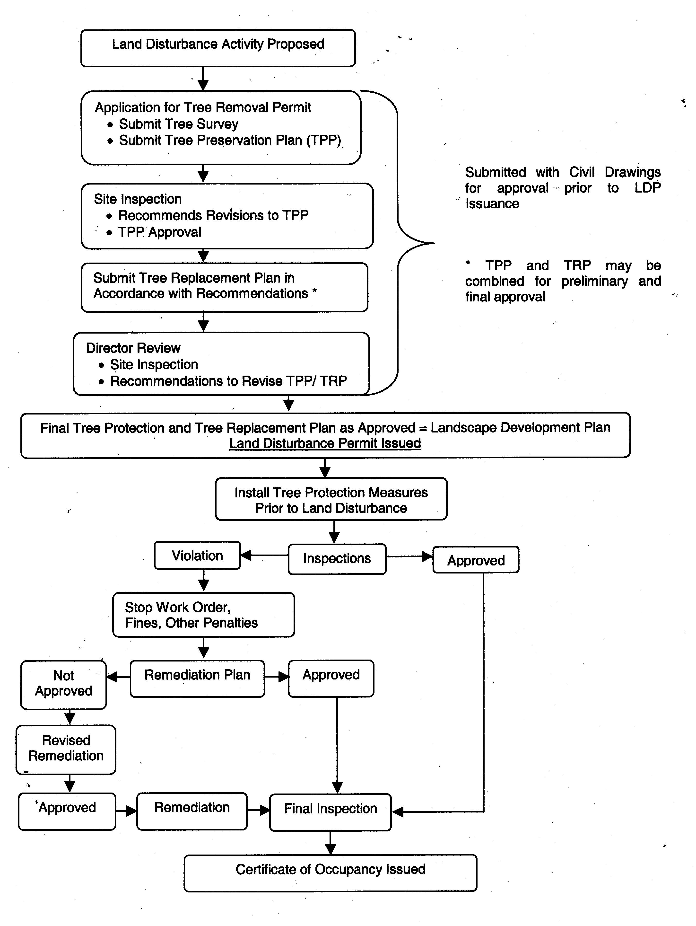
FIGURE 2 - sample survey

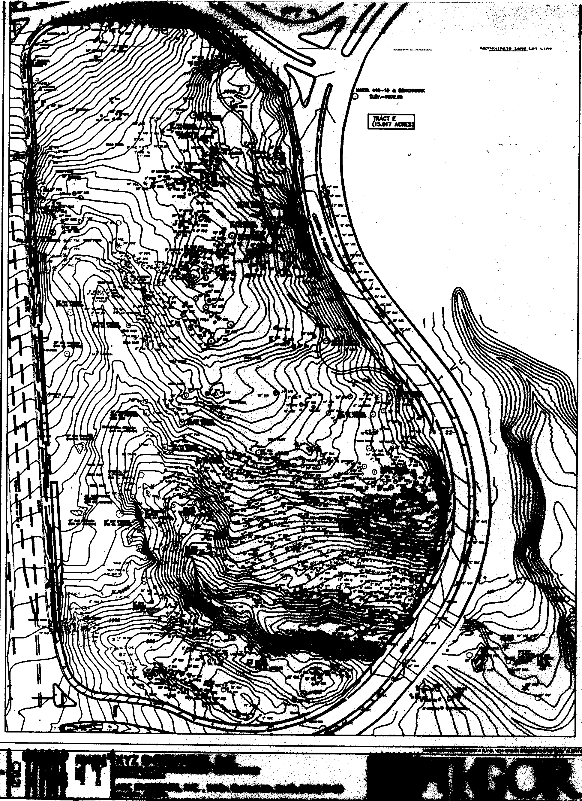
figure 3 - sample tree protection/replacement plan

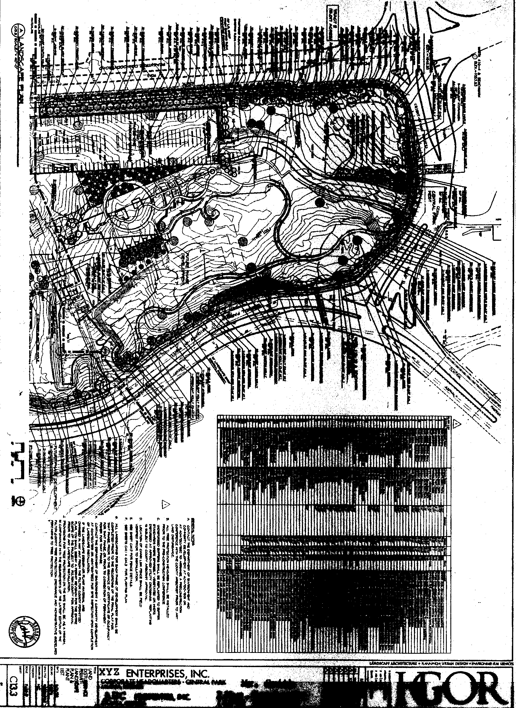
FIGURE 4 - critical tree protection zone

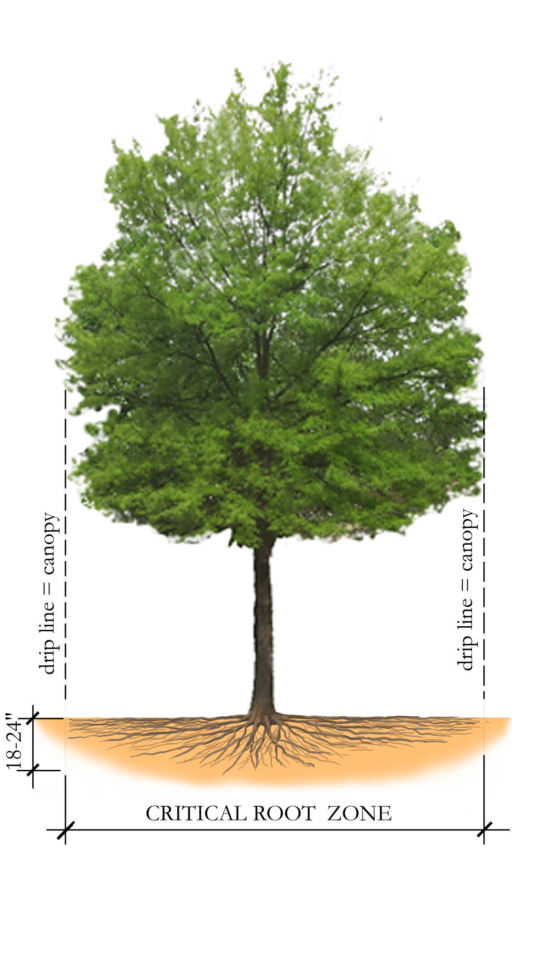
figure 5 - tree save area FENCING and SIGNAGE

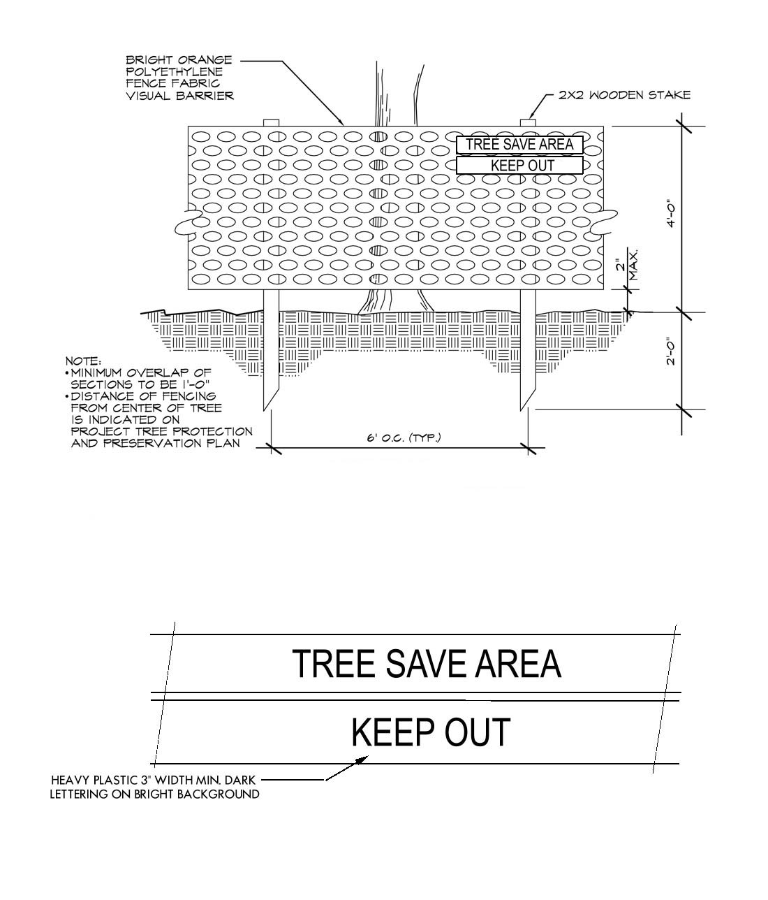
Figure 6 - on-site planting areas

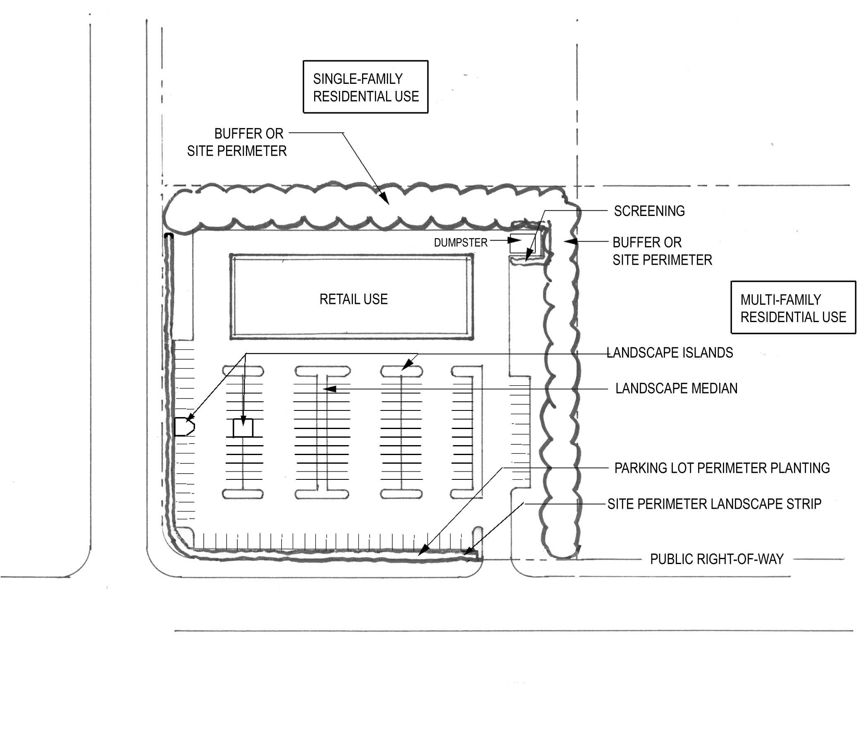

Figure 7 - typical Perimeter Planting

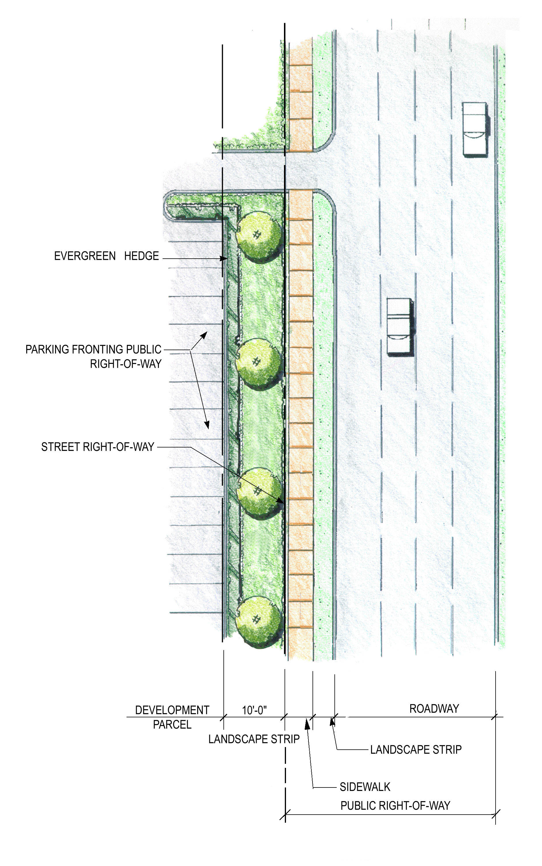
figure 8A - perimeter planting with trees in row

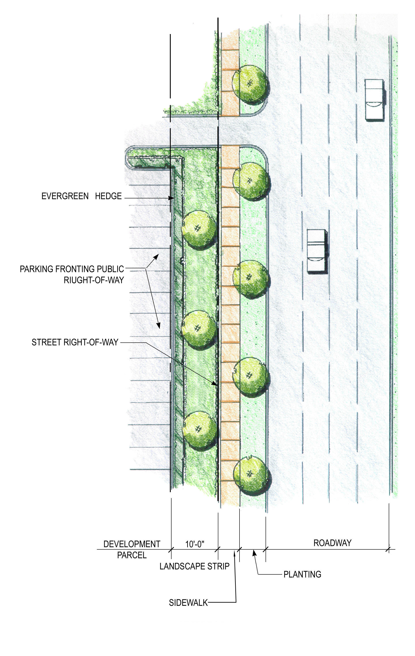
Figure 8B - perimeter planting with trees in row

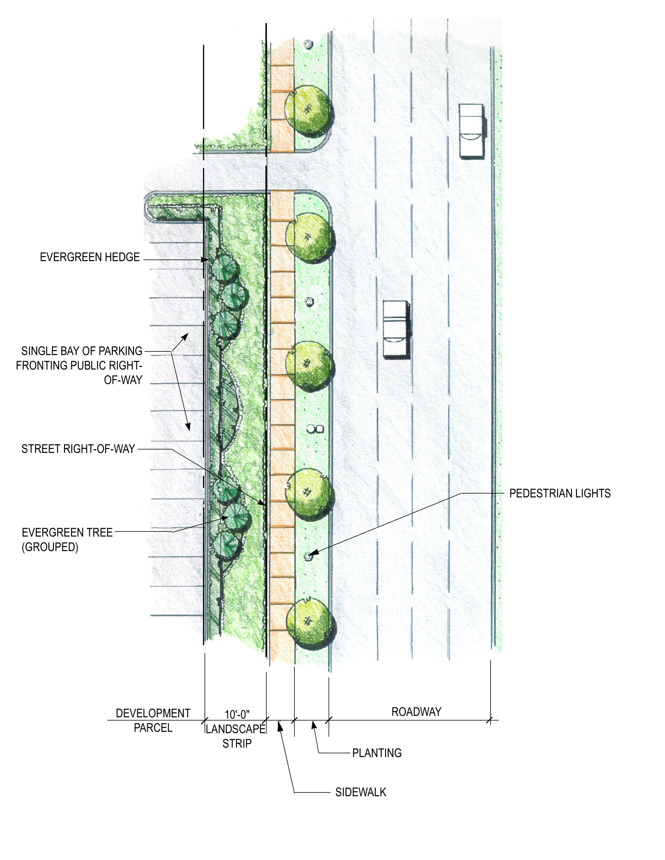
Figure 9 - Parking Lot Perimeter treatment,
hedge option

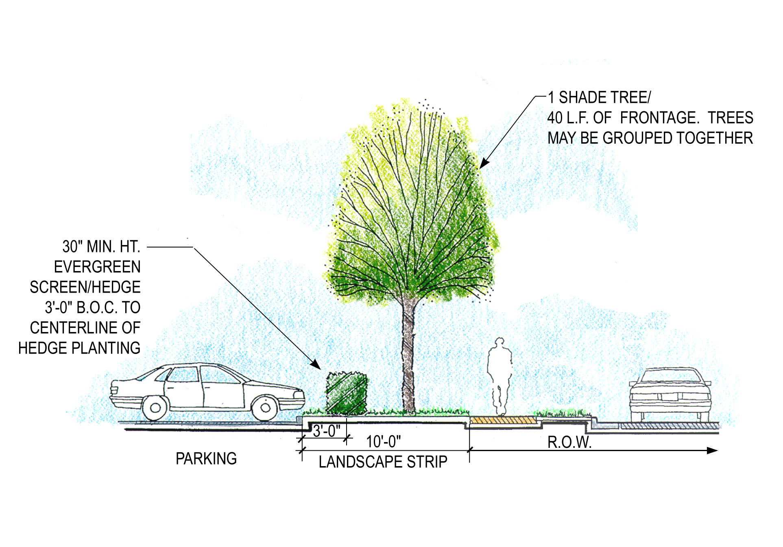
Figure 10 - Parking Lot Perimeter treatment,
wall option

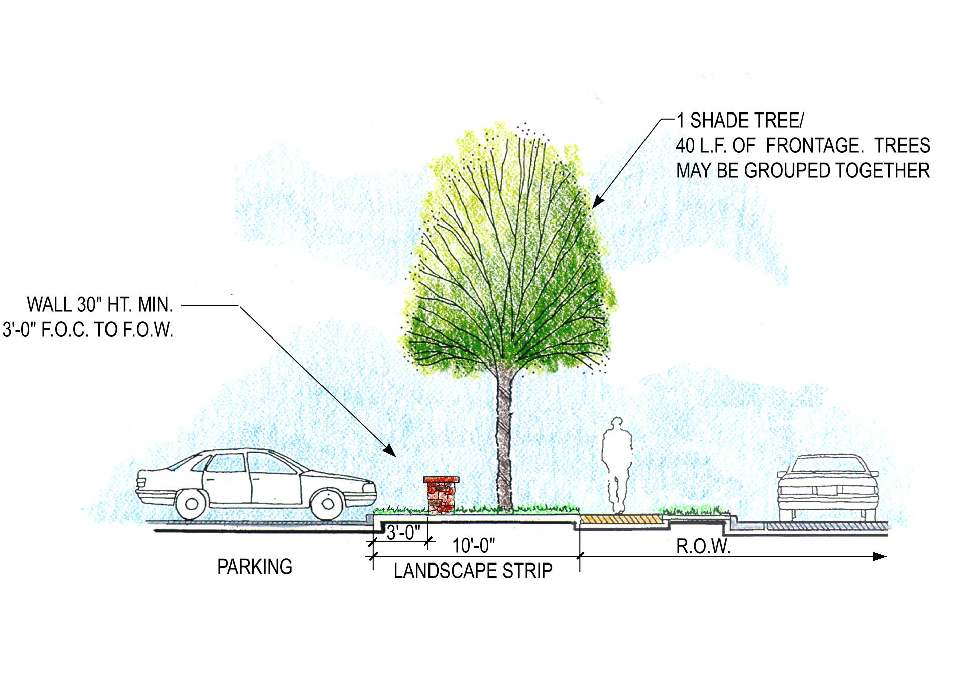
figure 11 - parking space planting Radius

70’ radius to a shade tree or
35’ to any other type tree

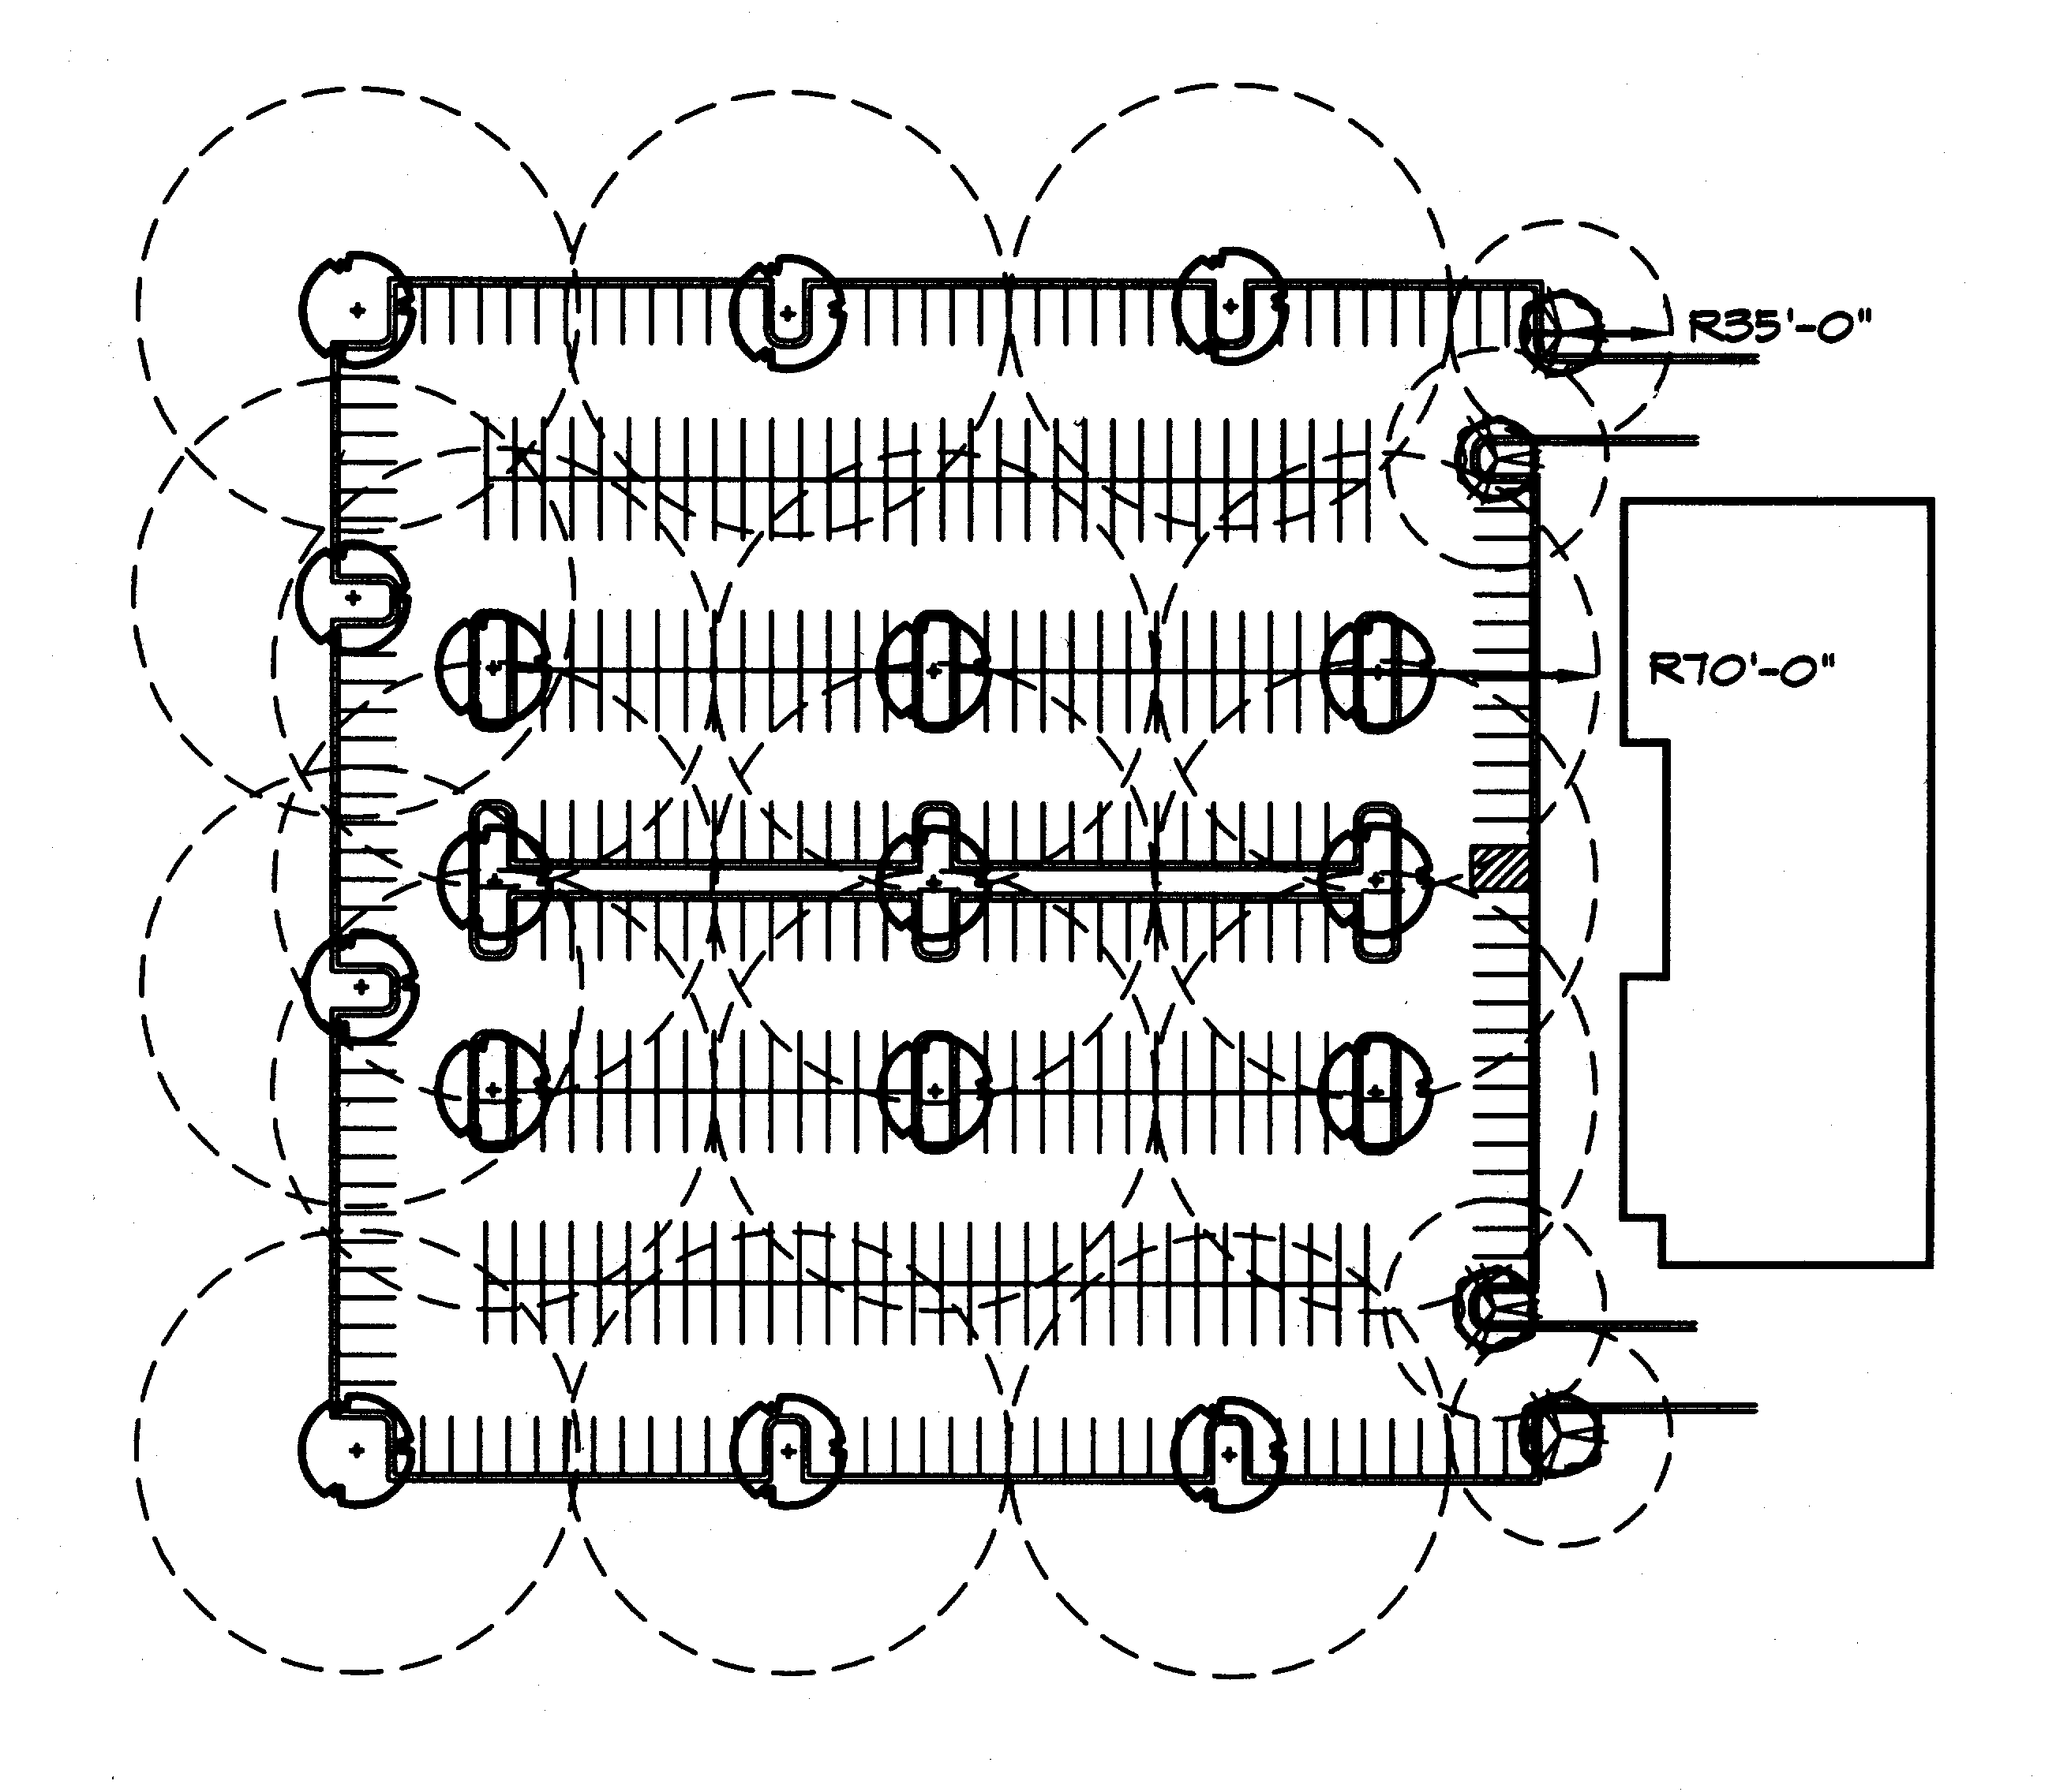
Figure 12 - Landscape Median Island options

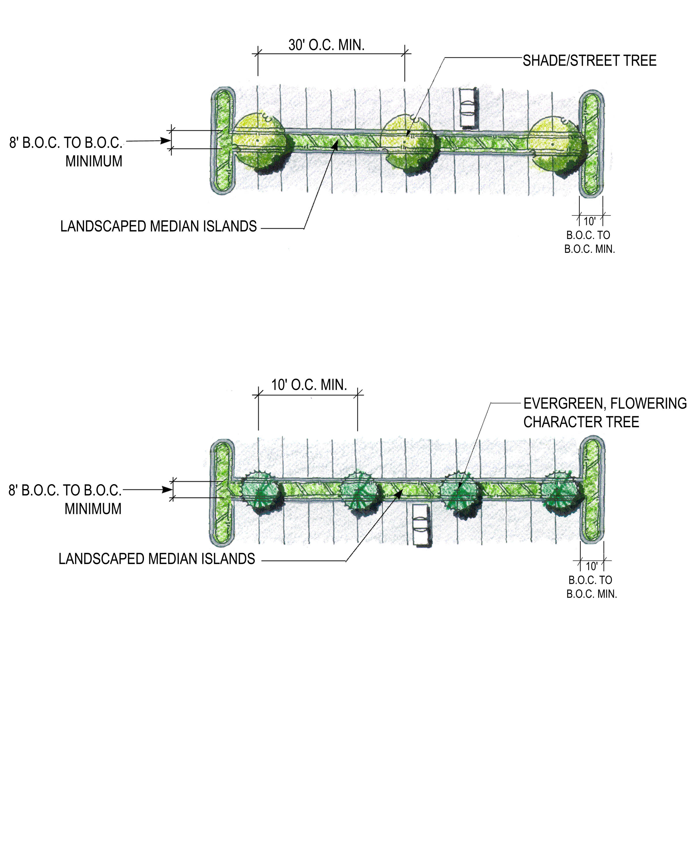
Figure 13 - Landscape End Island options

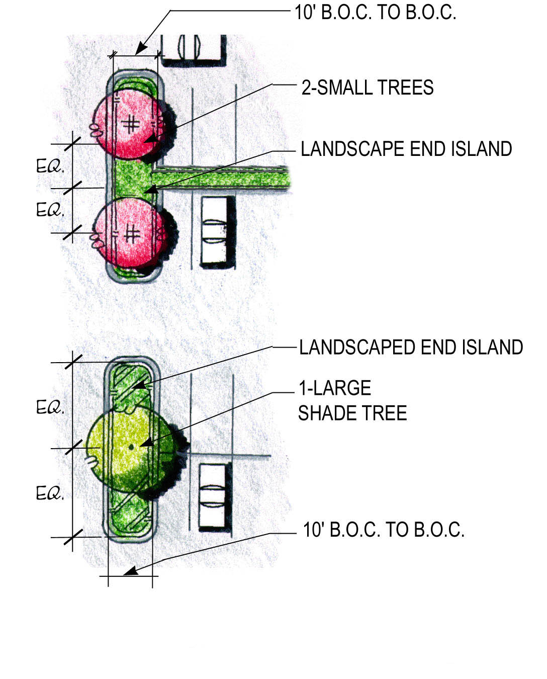
Figure 14a and 14B - tree Staking and guying details

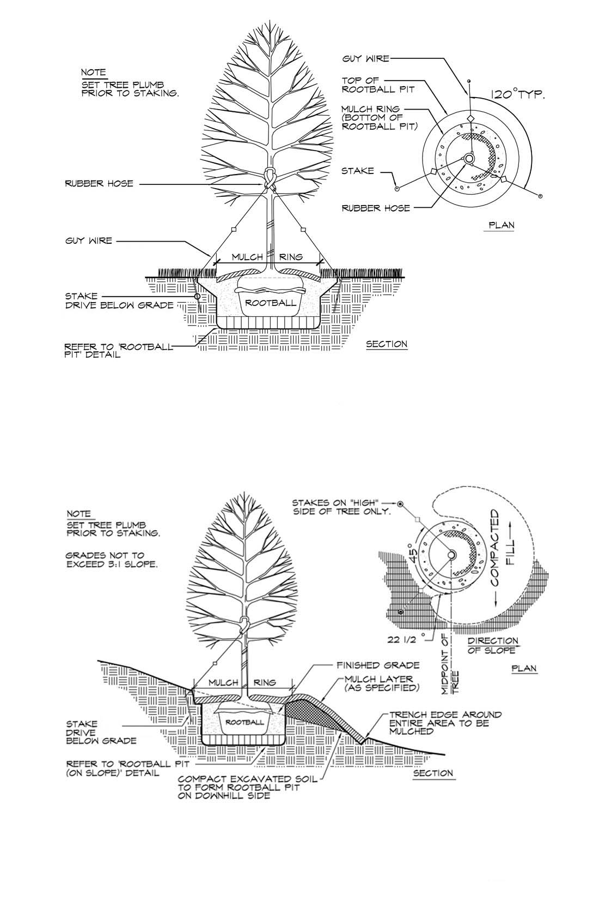
figure 15a and 15b - typical tree rootball pit

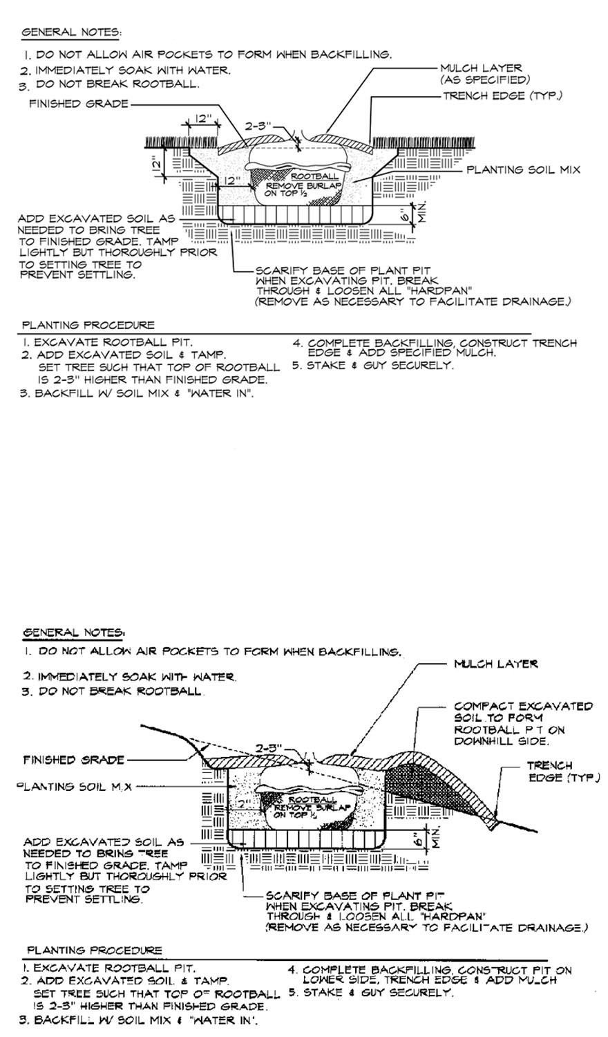
Figure 16 - avoidance of Utilities
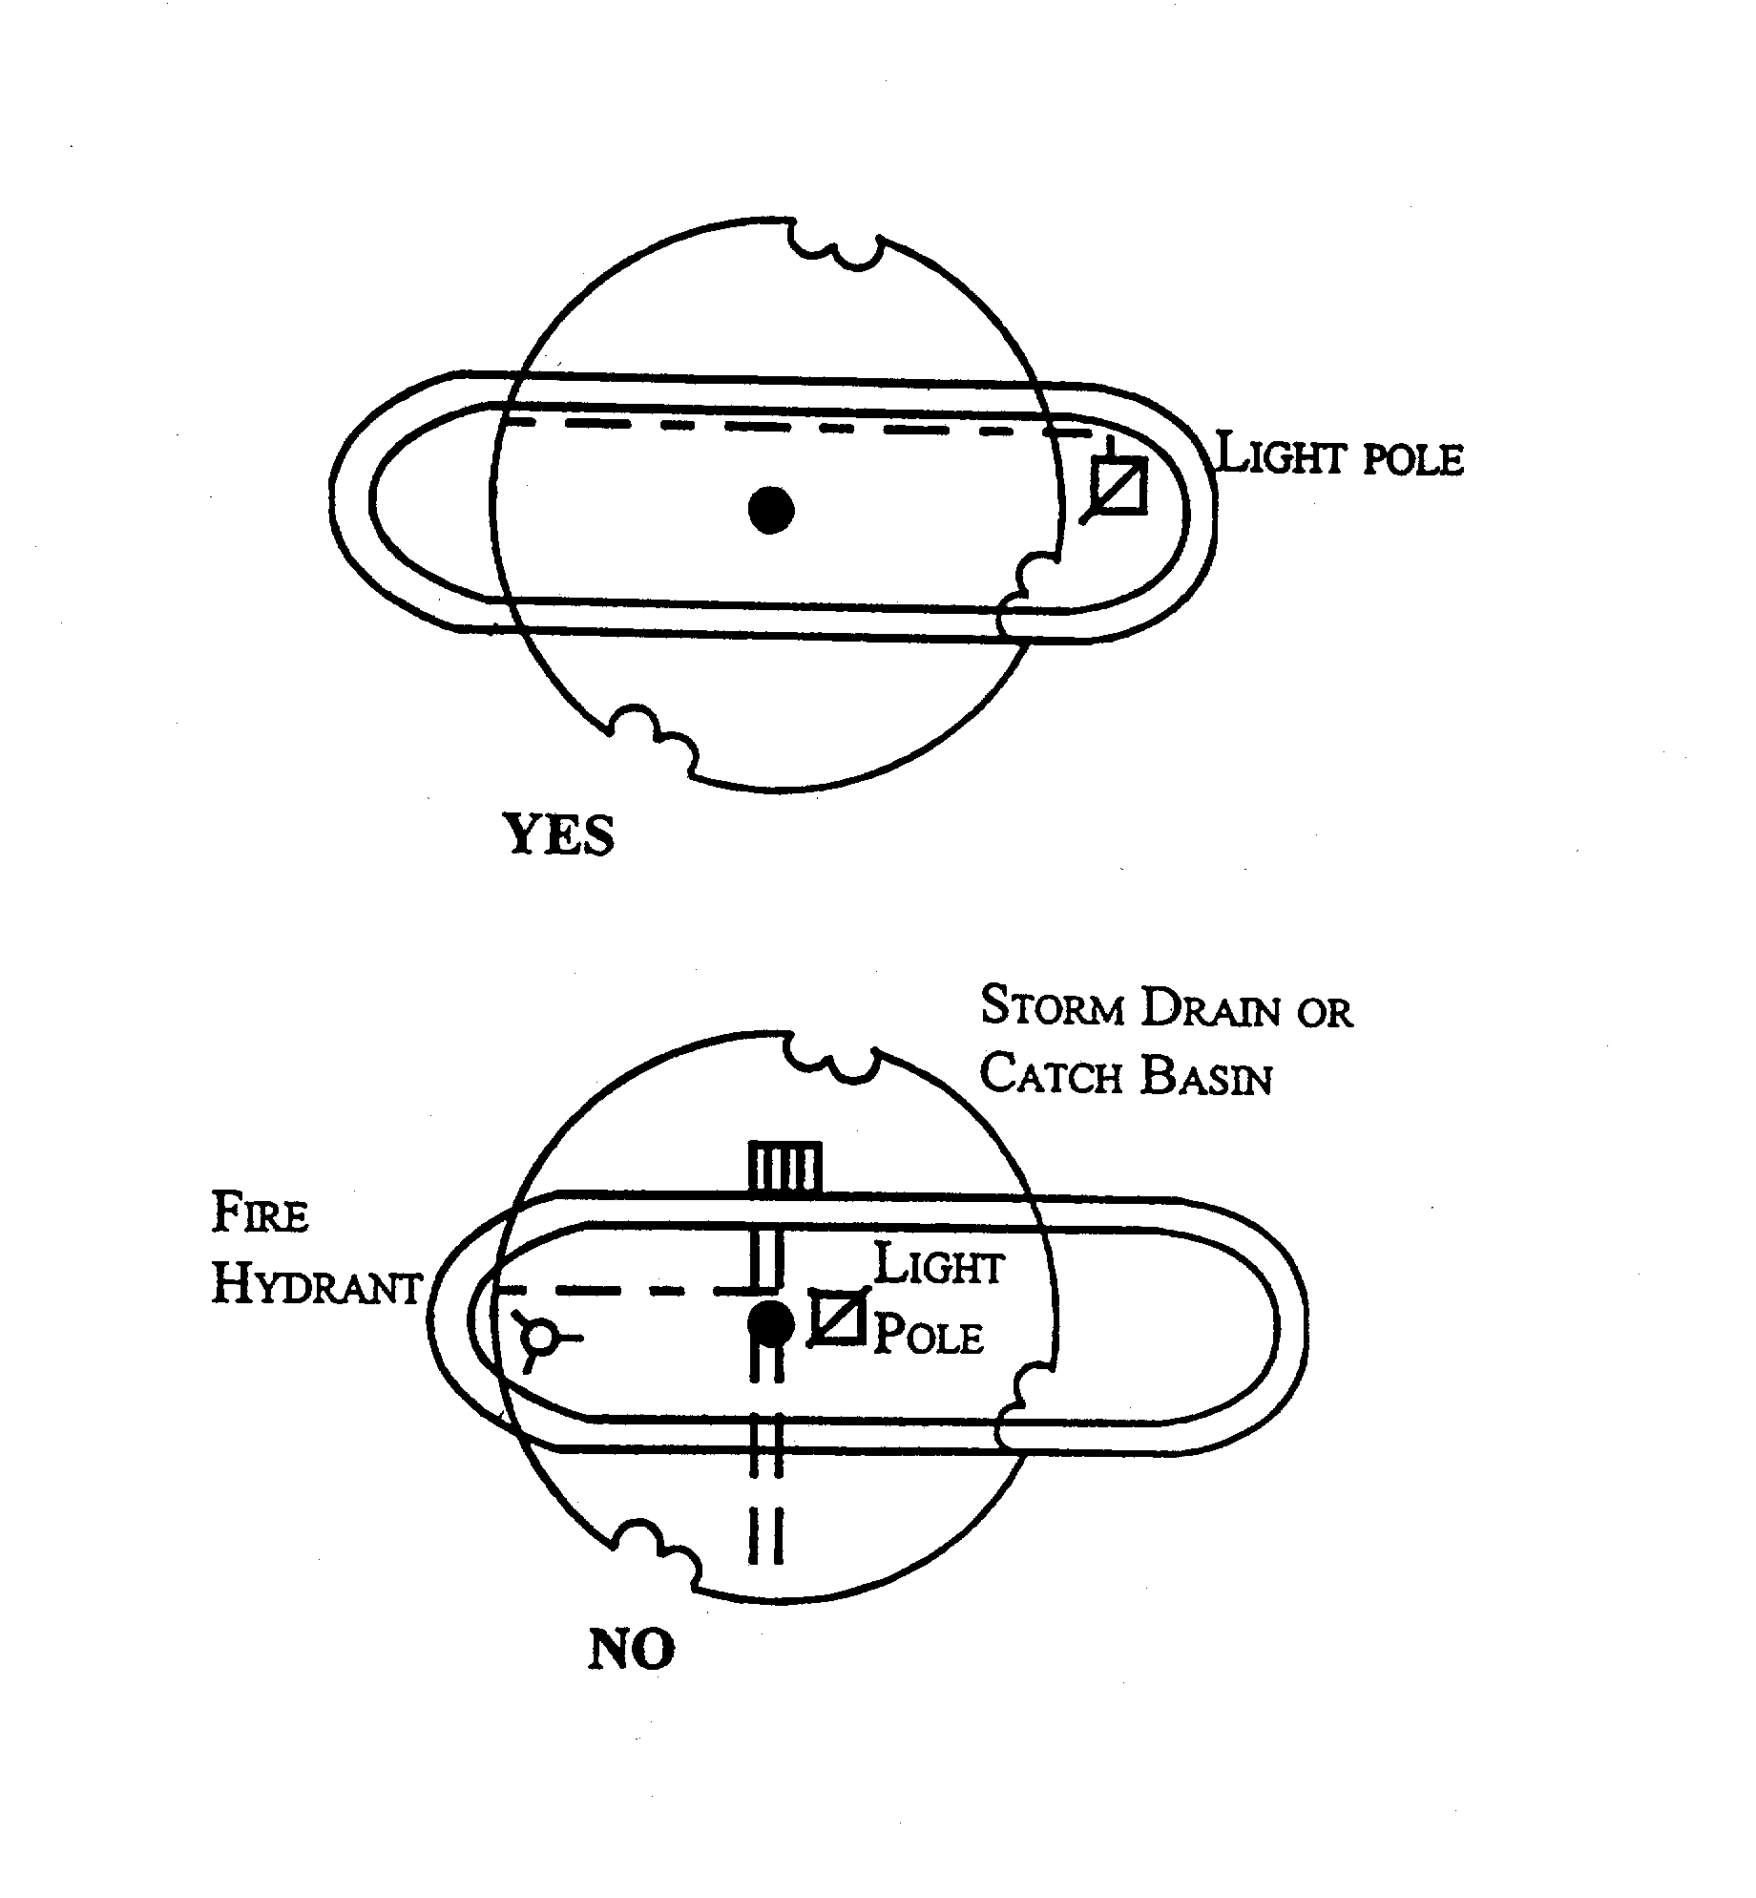

figure 17 - avoidance of Sight Triangles
